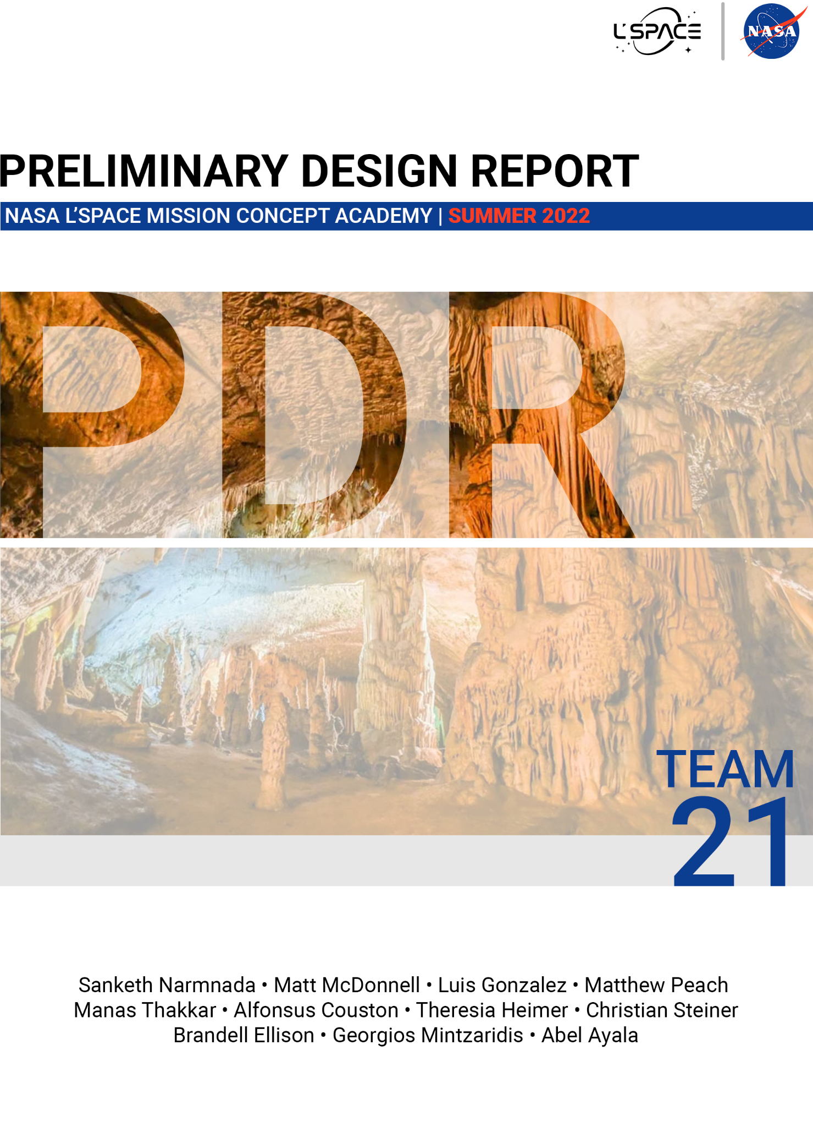**TABLE OF CONTENTS**

**SECTION 1** - Introduction & Summary **4**

1.1 Team Introduction 4

1.2 Mission Overview 6

*1.2.1 Mission Statement* *6*

*1.2.2 Complete Mission Requirements* *7*

*1.2.3 Mission Success Criteri**a 9*

*1.2.4 Concept of Operations* *9*

*1.2.5 Major Milestone Summary* *10*

1.3 Vehicle Design Summary 10

*1.3.1 Vehicle Design Overview* *10*

*1.3.2 Electronics Interactions* *12*

1.4 Payload & Science Instrumentation 12

**SECTION 2** - Evolution of Project **15**

2.1 Evolution of Mission Experiment Plan 15

2.2 Evolution of Vehicle Design 16

2.3 Evolution of Payload Science Instruments 20

**SECTION 3** - Vehicle & System Design **23**

3.1 Selection, Design & Verification 23

*3.1.1 System Overview* *23*

*3.1.2 Mechanical System Overview* *27*

*3.1.3 Power System Overview* *29*

*3.1.4 Communications & Data Handling Systems Overview* *43*

*3.1.5 Thermal System Overview* *48*

*3.1.6 FMEA & Risk Mitigation* *50*

*3.1.7 Performance Characteristics & Predictions* *55*

*3.1.8 Confidence & Maturity of Design* *56*

3.2 Recovery/Redundancy System 57

3.3 Payload Integration 58

**SECTION 4** - Science Instrumentation **60**

4.1 Selection, Design & Verification 60

*4.1.1 System Overview* *60*

*4.1.2 Subsystem Overview* *63*

*4.1.3 Manufacturing Plan* *65*

*4.1.4 Verification & Validation Plan* *65*

*4.1.5 FMEA & Risk Mitigation* *66*

*4.1.6 Performance Characteristics* *70*

4.2 Science Value 70

*4.2.1 Science Payload Objectives* *70*

*4.2.2 Science Traceability Matri**x 71*

*4.2.3 Payload Success Criteria* *71*

*4.2.4 Experimental Logic, Approach, & Method of Investigation* *72*

*4.2.5 Testing & Calibration Measurement* *76*

*4.2.6 Precision & Accuracy of Instrumentation 8**2*

*4.2.7 Expected Data & Analysis* *86*

**SECTION 5** - Safety **91**

5.1 Safety Officer & Safety Approach 91

5.2 Personnel Hazards & Mitigation 91

*5.2.1 Training Procedures* *91*

*5.2.2 General Mitigation (All Facilities)* *91*

*5.2.3 Machining/Manufacturing Hazards & Mitigation* *91*

*5.2.4 Testing Hazards & Mitigation* *92*

*5.2.5 General Testing Procedures* *93*

*5.2.6 Injury Procedures* *93*

**SECTION 6** - Activity Plan **94**

6.1 Mission Budget 94

6.2 Mission Schedule 96

6.3 Outreach Information 100

*6.3.1 Outreach Summary* *100*

*6.3.2 Outreach Goal**s 100*

6.4 Program Management Approach 101

*6.4.1 Team Organization Chart* *101*

*6.4.2 Decisions Regarding Team Structure* *102*

*6.4.3 Challenges* *102*

**SECTION 7** - Conclusion **104**

References105

**ACKNOWLEDGEMENTS**



We would like to dedicate this report to all our mentors, leaders, and every individual who devoted countless hours towards such a large project; one that became so successful in such a short amount of time.

*\* Cover image provided royalty-free from Shutterstock.*

# SECTION 1 - Introduction & Summary

# 

## 1.1 TEAM INTRODUCTION

|  | **PROJECT MANAGER** - Sanketh Narmnada   * Senior majoring in Aerospace Engineering at Iowa State University (Ames, IA) * Areas of Academic Interest: Orbital Mechanics, Systems Engineering/Mission Planning, and Nondestructive Evaluation * Hobbies: Watching racing, gaming, producing music, learning languages |
| --- | --- |
|  | **DEPUTY PROJECT MANAGER** - Matt McDonnell   * Junior majoring in Biomedical Engineering at the University of Iowa (Iowa City, IA) * Areas of Academic Interest: Computational Bioengineering, Medical Imaging Physics, and Public Health Informatics * Hobbies: Ice hockey, mobile app development, filmmaking, technology |
|  | **LEAD SYSTEMS ENGINEER** - Luis Gonzalez   * Senior majoring in Electrical Engineering at Texas A&M University (College Station, TX) * Areas of Academic Interest: Control Systems, RF and Antenna Engineering, Systems Engineering, Astrophysics * Hobbies: Sports (college football, soccer, and Formula 1), playing guitar, working out |
|  | **CHIEF SCIENTIST** - Matthew Peach   * Sophomore majoring in Software Development at Austin Community College (Austin, TX) * Areas of Academic Interest: C++20, SFML, Unreal Engine, Data Science, Kali Linux * Hobbies: Jeep off-roading, listening to audiobooks/podcasts, retro 2D graphics programming with SFML, staying up-to-date with modern C++ |
|  | **PLANETARY GEOLOGIST** - Alfonsus Couston   * Junior majoring in Geological Science & Planetary Exploration at Arizona State University (Tempe, AZ) * Areas of Academic Interest: Planetary Geology, Geology, Hydrology, Geophysics * Hobbies: Mountain Biking, Hiking, Playing Instruments, Learning Languages |
|  | **ELECTRICAL ENGINEER** - Abel Ayala   * Junior majoring in Mechatronics Engineering at Texas A&M University (College Station, TX) * Areas of Academic Interest: Control Systems, Computer Aided Drafting * Hobbies: Gaming, reading, guitar, tennis |
|  | **ELECTRICAL ENGINEER** - Brandell Ellison   * Sophomore majoring in Electrical Engineering at The University of Texas (Dallas, TX) * Areas of Academic Interest: Power Systems, Control Systems, and Automation * Hobbies: Fine scale modeling, CAD, sketching |
|  | **MECHANICAL ENGINEER** - Manas Thakkar   * Sophomore majoring in Aerospace Engineering at Embry-Riddle Aeronautical University (Daytona Beach, FL) * Areas of Academic Interest: Aeronautics, Dynamics and Space Control Systems * Hobbies: Gaming, CAD, working out, playing basketball |
|  | **HARDWARE ENGINEER** - Georgios Mintzaridis   * Junior majoring in Electrical Engineering at Texas A&M University (College Station, TX) * Areas of Academic Interest: Power distribution, Computer architecture, Circuit design, Very-Large-Scale-Integration (VLSI) * Hobbies: Sports (mostly basketball), working out |
|  | **HARDWARE ENGINEER** - Christian Steiner   * Junior majoring in Computer Engineering at the University of Minnesota (Twin Cities, MN) * Areas of Academic Interest: Computer Aided Design, Graphics, Machine Learning, Computer Architecture * Hobbies: Ultimate frisbee, disc golf, pickleball, drawing |
|  | **THERMAL ENGINEER** - Theresia Heimer   * Freshman majoring in Mechanical Engineering at Texas A&M University (College Station, TX) * Areas of Academic Interest: Robotics, CAD, Heat Transfer * Hobbies: Teaching/mentoring robotics & model rocketry, soccer, volunteering |

## 1.2 MISSION OVERVIEW

### 1.2.1 MISSION STATEMENT

The purpose of this mission is to study a selected cave on Mars and help determine if Martian caves are capable of human habitation. From this, three science objectives were introduced. These three objectives involved temperature, radiation, and the evaluation of cave structural stability. After this, a cave was selected for the concept to traverse through. The cave is a lateral type, meaning that the cave entry is on the side of a formation, making the cave egress easier. With these in mind, a concept was developed with four science instruments to complete the objectives. These four science instruments are the Radiation Assessment Detector (RAD), LiDAR Scanner, Alpha Particle X-Ray Spectrometer (APXS), and the Rover Environmental Monitoring Station (REMS). The RAD will collect radiation data to see if the levels experienced in a cave will be low enough for humans to thrive. The LiDAR scanner will be used to form a model of what the cave structure would look like, which would help in addressing challenges for habitation within lateral caves. The APXS will collect chemical composition data through the display of different spectra in samples, which can help determine what parts of caves are more vulnerable to collapse compared to others. The REMS will collect temperature data to see how low of a temperature a spacesuit would need to be designed for in future missions with that environment.

### 1.2.2 COMPLETE MISSION REQUIREMENTS

**Mission Constraints**

* The mission concept must have a mass less than 50 kg.
* The mission concept may not exceed the dimensions of 1.5m x 1.5m x 1.5m.
* The mission concept must relay communications to Earth via the lander it arrived on.
* The budget of the mission is capped at $300 million.

**High-Level Requirements**

* The mission concept shall weigh less than 50 kg.
* The mission concept shall have a volume less than 1.5m x 1.5m x 1.5m.
* The mission concept shall communicate with the lander it arrived on.
* The mission concept shall cost less than 300 million dollars.
* The mission concept shall be able to enter and traverse a cave on Mars.
* The mission concept shall be able to collect rock samples from the cave.
* The mission concept shall be able to collect and log temperate data from the cave systems on an hourly basis
* The mission concept shall be able to collect and transmit radiometric data to the lander
* The mission concept shall be able to periodically capture and interpret panoramic snapshots of the cave environment to the lander.
* The mission concept shall be able to continuously map the cave systems and generate a point cloud model to transmit to the lander.

**Subsystem Requirements**

**Chassis**

Since the mission will study a cave on Mars, the major threat to the mission endurance over time will be failing rocks. To encounter this hostile environment while remaining within the mission’s weight requirement, Aluminum alloys with titanium seem to be the best combination of lightweight and resistance from rock impacts.

* The chassis must be able to withstand weight of all subsystems and instruments
* The chassis must weight less than 30 kg
* The chassis must cover the power system completely

**Power**

For providing power to the rover inside the Martian caves, a solar panel shall be used. Rovers previously used on Mars explorations have also used the idea of a solar panel and rechargeable batteries. The multi - panel solar plates look like “wings” on the rover, which can generate up to 960 - 1000W power on a normal day on Mars. Since the mission is also carried during night, rechargeable lithium ion batteries are the option. Generally, these batteries are 18cm x 65cm x 3cm in size, and the rechargeable batteries can provide upto 1200W of power for 8 hours straight. These are rechargeable and hence can be reused multiple times. This can thus provide energy to the rover all round the day.

**Thermal**

To keep the mission’s vehicle fully functional, it was needed to find ways to encounter the low temperatures inside the Cave. The following method were chosen as the thermal components of the missions and the reason is because all of the following have proved to efficiently work in the extreme experature of Mars:

* Heaters:
  + Heat coming from electronics
  + All-Polyimide Heaters (AP Heaters)
* Insulation:
  + Aerogel
* Temperature Control
  + Thermostats
  + Heat Switches

**Mobility**

* The vehicle shall use wheels as its mobility method to traverse the cave's interior.

**Communications**

* Must be less than 4 kg
* Antenna must be less than 300 mm high
* Antenna must be less than 300 mm in diameter
* Overall subsystem must cost less than $25 million
* Must withstand temperature and radiation ranges of Mars
* 8 MBps data rates

### 1.2.3 MISSION SUCCESS CRITERIA

**Radiation Success Criteria**

* Record 360 minutes (15 minute readings every hour over one sol) of radiation readings from the RAD just outside of the target cave.
* Record radiation readings from the RAD for 15 minutes each hour for the duration of cave exploration.
* Send the data obtained to an active NASA Mars orbiter (Mars Odyssey or Mars Reconnaissance).

**Temperature Success Criteria**

* Record 24 thermal images of the mouth of the target cave from the outside (one picture per hour for one sol).
* Continually record thermal images for the duration of cave exploration.
* Send the data obtained to an active NASA Mars orbiter (Mars Odyssey or Mars Reconnaissance).

**Cave Structural Integrity Success Criteria**

* Record one spectrogram of the target cave floor.
* Record one spectrogram per sol for the duration of cave exploration. Each spectrogram shall be at least 5 meters apart and on the cave wall.
* Send the spectrograms obtained to an active NASA Mars orbiter.
* Record LiDAR data for the traversable portion of the target cave.
* Send the LiDAR data obtained to an active NASA Mars orbiter.

### 1.2.4 CONCEPT OF OPERATIONS

The Concept of Operations (ConOps) covers a basic timeline and description of the different phases of the mission, from entering the cave to collecting data and sending that data back to Earth.

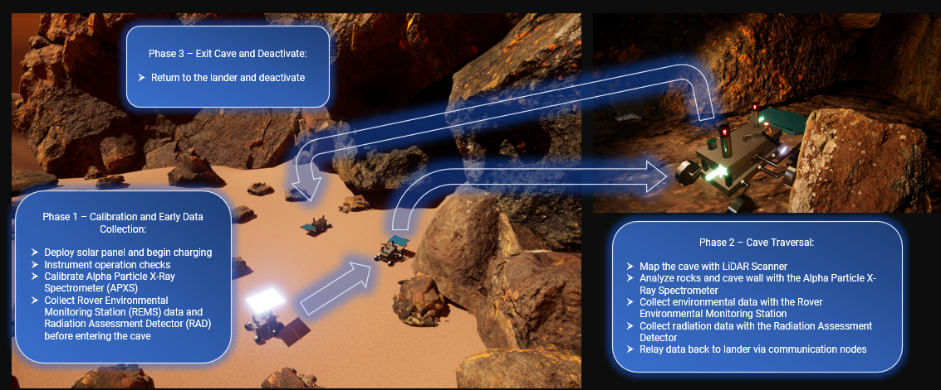

### 

### 1.2.5 MAJOR MILESTONE SUMMARY

**Phase A:** Initial research completed - **August 26, 2022**

**Phase B:** Subsystem designs and instrumentation chosen - **October 30, 2022**

**Phase C:** Preliminary Design Review - **February 7, 2022**

**Phase D:** Critical Design Review - **October 11, 2023**

**Phase D:** Subsystem fabrication complete, Test Readiness Review - **July 13, 2025**

**Phase E:** Concept is assembled, tested, and ready to launch - **August 17, 2026**

**Phase F:** Mission completed - **April 16, 2027**

## 1.3 VEHICLE DESIGN SUMMARY

### 1.3.1 VEHICLE DESIGN OVERVIEW

The concept will be a rectangular board that has two stages. The first stage stores major electrical components, which are the power distribution electronics, batteries, and computer hardware. The wiring from the electronics in the first stage will be fed through a tube up to the second stage. The second stage stores all of the science instrumentation and the thermal regulation electronics and hardware. The concept will feature a 6-wheel mobility system with adjustable height through the use of robotic legs. It will communicate with the lander using a UHF Antenna with smaller communication nodes dropped at specific distance intervals (mentioned in 3.1.4 and 3.2). Thermal control will be achieved through the use of radioisotope heater units, aerogel insulation, an internal thermometer, and heat switches. The concept will be powered by solar energy by obtaining energy through solar panels and storing it in three lithium ion batteries.

Four science instruments will be utilized for this mission. These include the Radiation Assessment Detector (RAD), LiDAR scanner, Alpha Particle X-Ray Spectrometer (APXS), and Rover Experimental Monitoring Station (REMS). The RAD will be used to monitor radiation levels inside and outside of the cave. The LiDAR scanner will be used to scan and map the structure of the cave. It will also be used to avoid obstacles while the concept is traveling to the site. The APXS will be used to look for signs of cave structure vulnerabilities using spectra of different minerals and elements. The REMS will be used to monitor temperature variations inside and outside of the cave.

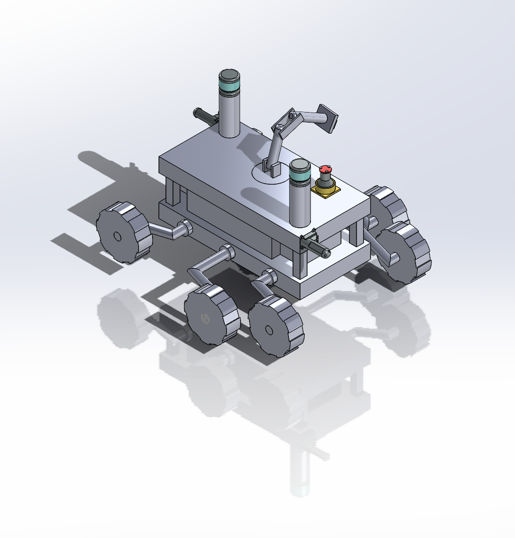

**Specifications**

Chassis Dimensions: 1m x 0.5m x 0.5m

Wheel Diameter: 20 cm

### 1.3.2 ELECTRONICS INTERACTIONS

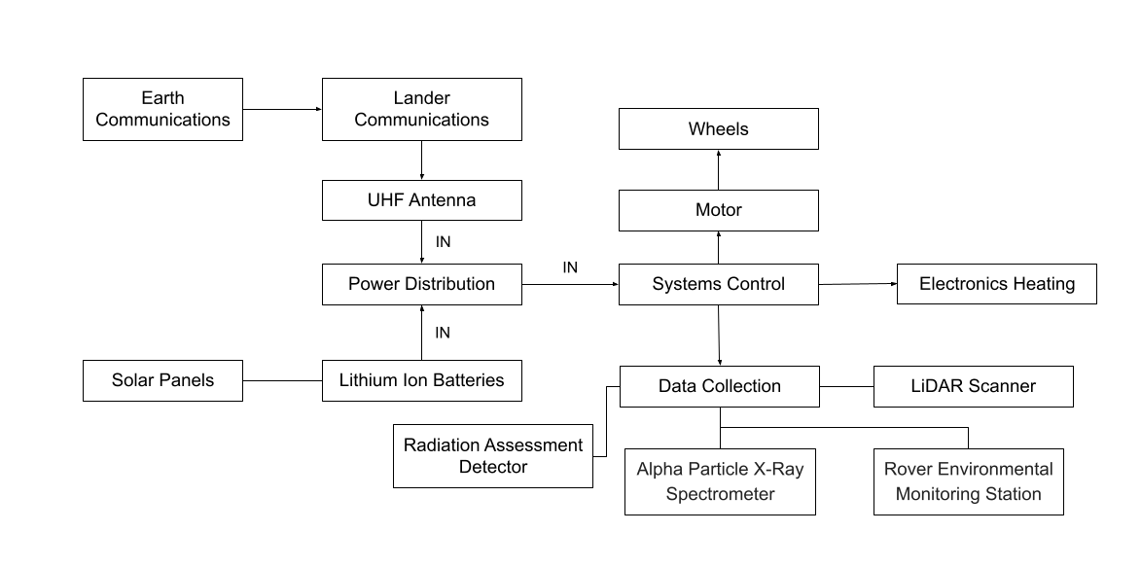

There are two sources of input going into the power distribution unit. These are communication signals from the control center and power from the batteries. The communication signals provide control signals to the power distribution, while the batteries provide energy to the concept. From the power distribution, different subsystems can be controlled. This includes major subsystems and science instruments.

**Science Instrument: Radiation Assessment Detector (RAD)**

* Used on the Mars Curiosity Rover
* Identifies high-energy particles to determine radiation levels on the surface of mars
* RAD is a charged particle telescope (made of three solid-state detectors) and a cesium iodide calorimeter
* An additional BC-432 scintillating plastic channel is used together with the CsI calorimeter and an anti-anticoincidence shield to detect and characterize neutral particles (i.e., neutrons and gamma rays).
* Does not have to be fully powered continuously; sample measurements can be taken hourly. Curiosity’s RAD only runs 15 minutes every hour.
* Must be faced towards the sky. Will be placed on top of the vehicle.

Source: [RAD for Scientists | RAD – NASA Mars Exploration](https://mars.nasa.gov/msl/spacecraft/instruments/rad/for-scientists/) https://pds-ppi.igpp.ucla.edu/data/MSL-M-RAD-2-EDR-V1.0/DOCUMENT/RAD_EDR_SIS.PDF

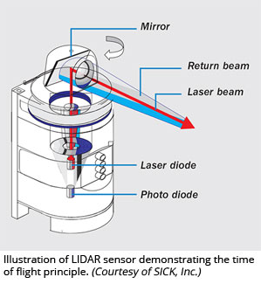

**Science Instrument: LiDAR Scanner**

* LiDAR scanners target a surface with a laser and measure the time for the reflected light to return to the receiver. This can be used to make a 3D representation of the target cave.
* May have one mounted on a flexible arm or multiple stationary scanners on the vehicle.
* Must protect the lens from sandstorms with a shutter.

**Science Instrument: Alpha Particle X-Ray Spectrometer (APXS)**

* Determines the elemental chemistry of rocks and regolith.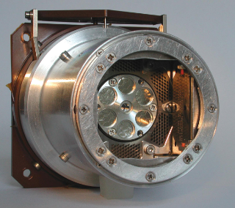
* Emits alpha particles from a source, which bounce back from the science target into a detector in the APXS, along with some X-rays. The X-rays result from the science target being excited from the alpha particle emission.
* The energy distribution of the bounced-back alpha particles and X-rays are analyzed to determine the elemental composition of the sample.
* Data can be used to gain information about the formation of the cave interior.

Source: [Alpha Particle X-Ray Spectrometer (APXS) - NASA Mars](https://mars.nasa.gov/mer/mission/instruments/apxs/)

**Science Instrument: Rover Environmental Monitoring Station (REMS)**

* Measures atmospheric pressure, temperature, humidity, winds, and UV radiation levels.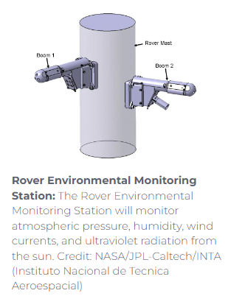
* Records at least 5 minutes of data at 1 Hz each hour over one sol.
* Can run (at most) 3 hours per sol.
* The instrument must be mounted onto a “chimney” to measure changes in pressure. A filter will be necessary to protect the sensor from dust.

Source: [https://mars.nasa.gov/msl/spacecraft/instruments/rems](https://mars.nasa.gov/msl/spacecraft/instruments/rems/#:~:text=MEDLI-,REMS,meteorological%20conditions%20around%20the%20rover)

# 

# 

# 

# SECTION 2 - Evolution of Project

## 

## 2.1 EVOLUTION OF MISSION EXPERIMENT PLAN

**Iteration 1:**

* **Mission:** Search many candidate caves to find the one best fit for long-term equipment storage.
* **Issue - Scope too Large:** Mars cave exploration has not been done before. It would be best to simply explore one cave.
* **Issue - Where is the Science?:** This was not exactly an exploration mission. It is uncertain that this information could have been useful to anyone.

**Iteration 2:**

* **Mission:** Measure radiation levels and temperature in a cave along searching the cave for signs of life.
* **Issue - Signs of Life:** “Signs of life” is a large umbrella term. To identify signs of life would require many diverse instruments. The search-for-life is better left for a more specialized mission with better resources.

**Iteration 3:**

* **Mission:** Identify if a cave would be a suitable habitat for future human colonizers.
* **Issue - Is This Useful?:** A cave on Mars is *probably* not so radically different from the surface of Mars that it would be significantly more suitable for human habitation.
* Since it is unknown whether or not the environmental differences between the surface and a cave are significant enough to take into consideration when planning human habitation, it would be useful to obtain data on that.

**Final Iteration:**

* **Mission:** The conditions inside of Mars’ caves differ from those on the more-studied surface. By analyzing these differences, the caves may prove useful for future missions.

## 2.2 EVOLUTION OF VEHICLE DESIGN

**Design 1:**

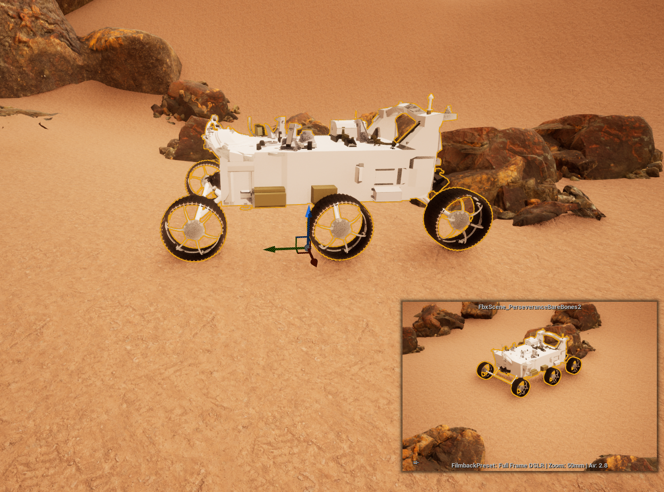

The Perseverance rover was used as a case study in the basic layout.

Sporting a 3 m x 2.7m x 2.2 m chassis, the Perseverance weighs approximately 1025 kg. Designed to carry and protect the computer, electronics, and payload instrument systems, it borrows heavily from the MSL Curiosity rover’s design while Incorporating a new science toolbox, a coring drill, an Internal Instrumentation workspace, and a Sampling and Caching workspace

In communication, the rover used three different antennas: UHF, X-band low gain, and X-band high gain. The X-band antennas provide direct data transmission without using satellites, whereas the UHF supports larger data transmissions with the use of orbiters. Implementing all three antennas would damage the mission. The UHF antenna is the most important and secure option for its capability of maintaining signal with orbiters, transferring more data, and low weight. By implementing the two X-band antennas it would make the rover heavier and it is likely that signal would be lost inside a cave, therefore making them useless to the mission. For the purposes of the mission, a Perseverance-based design was determined to be too tall, too heavy, and too expensive for transport as a secondary payload. As such, it would not satisfy the needs of the mission in its current configuration.

**Design 2:**

After conducting research on the instrumentation needs of our science mission, we realized that our environment posed serious limitations in regards to the form factor of our machine.

**New Rover Concept:**

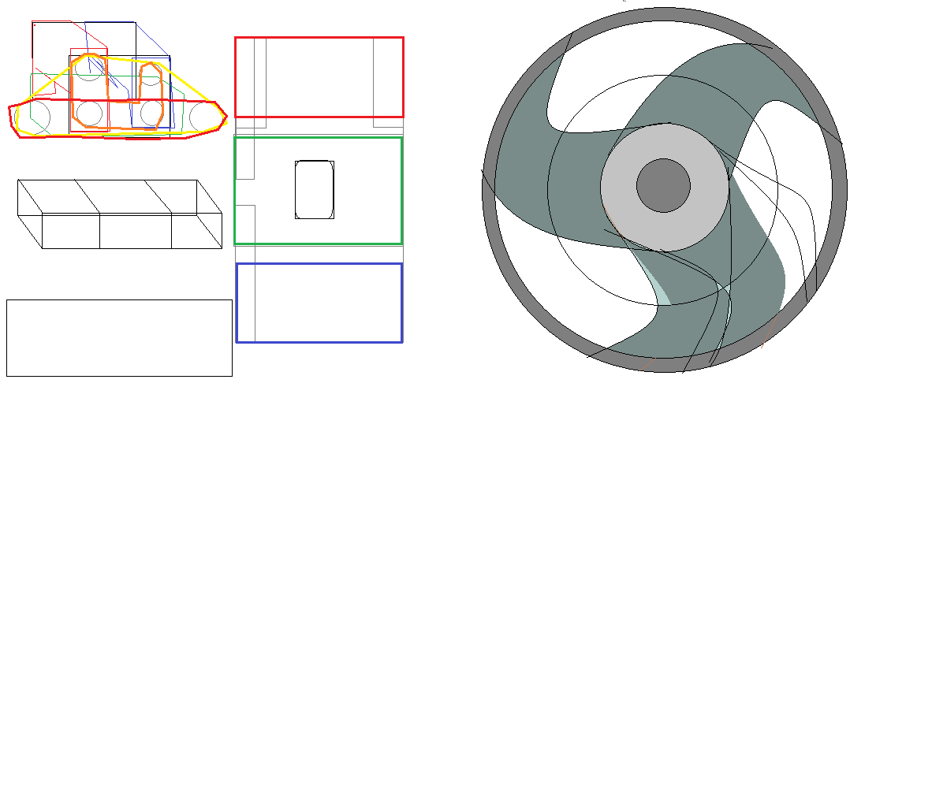

* A novel folding chassis design for a tri-segmented rover was proposed.
  + A variable profile complies with payload transport volume limitations,
  + The “briefcase” form factor would provided separation to components that might interfere with one another
    - Instruments that are responsible for navigation and remote sensing are placed in a frontward facing portion of the machine.
    - Essential power supply systems, heat rejection systems, and acoustic equipment for subterranean imaging are given center mass for weight distribution.
    - Characterization and communication equipment are placed on the rear, avoiding emissions based remote sensing equipment
* The system is to use a 6x6x4+4wd style of locomotion with directional wheels designed to crawl the machine in one direction whilst rolling it in another,
  + Untested feature better suited by traditional wheel designs
    - Not married to this concept to function.

The chassis design’s primary advantages:

* Ability to reduce it’s profile to half of it’s vertical dimension
  + Fringe benefit of folding along its posterior and anterior ends
  + In the event of a deep freeze, the machine can fold to orient all components to within proximity of central heating elements
    - The integration of COTS hardware such as digital gyroscopes and accelerometers will enable the probe to minimize the risk of the machine rolling over.
  + Partial utilization of this feature also creates a flexible mast for rotating lidar, thermal, and radioimaging scanners
    - can fit through choke points smaller than the aforementioned 1.5 m vertical measure. With strategic placement of imaging sensors, this design allows for horizontal snapshots of nearby features as well as continuous vertical scanning during horizontal locomotion.

Communications

* A helical structure RUHF antenna with a mass of around .5 kg will be constructed for the rover. The cylindrical antenna supports frequencies of 400MHz and it is capable of transferring 8MBps. It will be placed on the back of the rover right above the transceiver. The transceiver will operate within the same frequencies and 15W of power from the battery. The dimensions are: 16cm W, 20.3cm D, 10.4cm H. The weight is 3kg.

**Design 3:**

Analysis of the ExoMars Rover (Concept C) was performed as the third case study for our rover design.

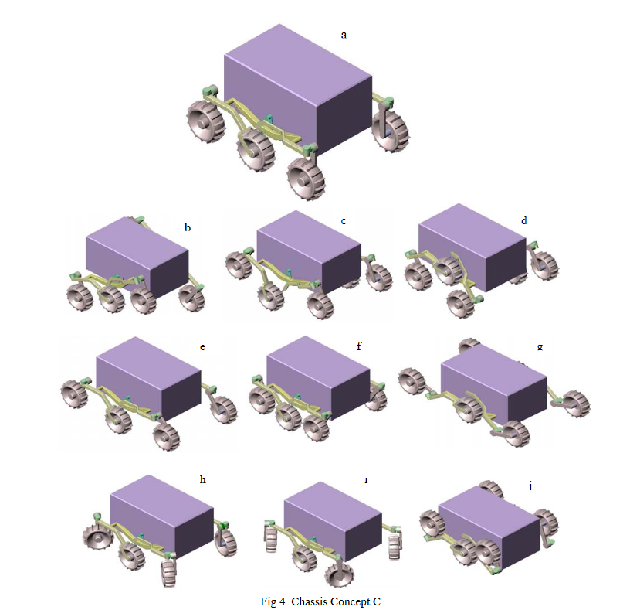

* Concept C: Locomotion w/ 6x6x4+4WD
  + Hinge-lever (“Rocker-Bogie”) mechanism provides balance on three/six wheels, connected across the payload area by an averaging linkage
  + Rotation is constrained to identical angles in opposite directions.
  + Corner wheels are powered, center ones exist to provide stability.
  + Ensures negotiation of 25° inclines
  + Hinge design ensures better stabilization during movements along inclines/ crossing hills.
  + Offers a more varied number of storage and deployment options
  + Added the ability to include two remote radio communication nodes to expand the wireless capabilities of the rover

Certain features were inherited from the two prior concepts

* + Retained:
    - Segregation of components (From 2)
    - Centralization of mass (From 2)
    - 6x6x4 chassis (From CC)
    - Levered hinge design (From CC)
  + Abandoned:
    - ExoMars concept of ”Walking” deemed unnecessary for mission parameters (New Frontiers idea w/ New Frontiers implementation costs in Discovery class mission)

Source: <http://robotics.estec.esa.int/ASTRA/Astra2004/Papers/astra2004_D-05.pdf#page=1&zoom=auto,-16,5681111>



Communication Antenna:

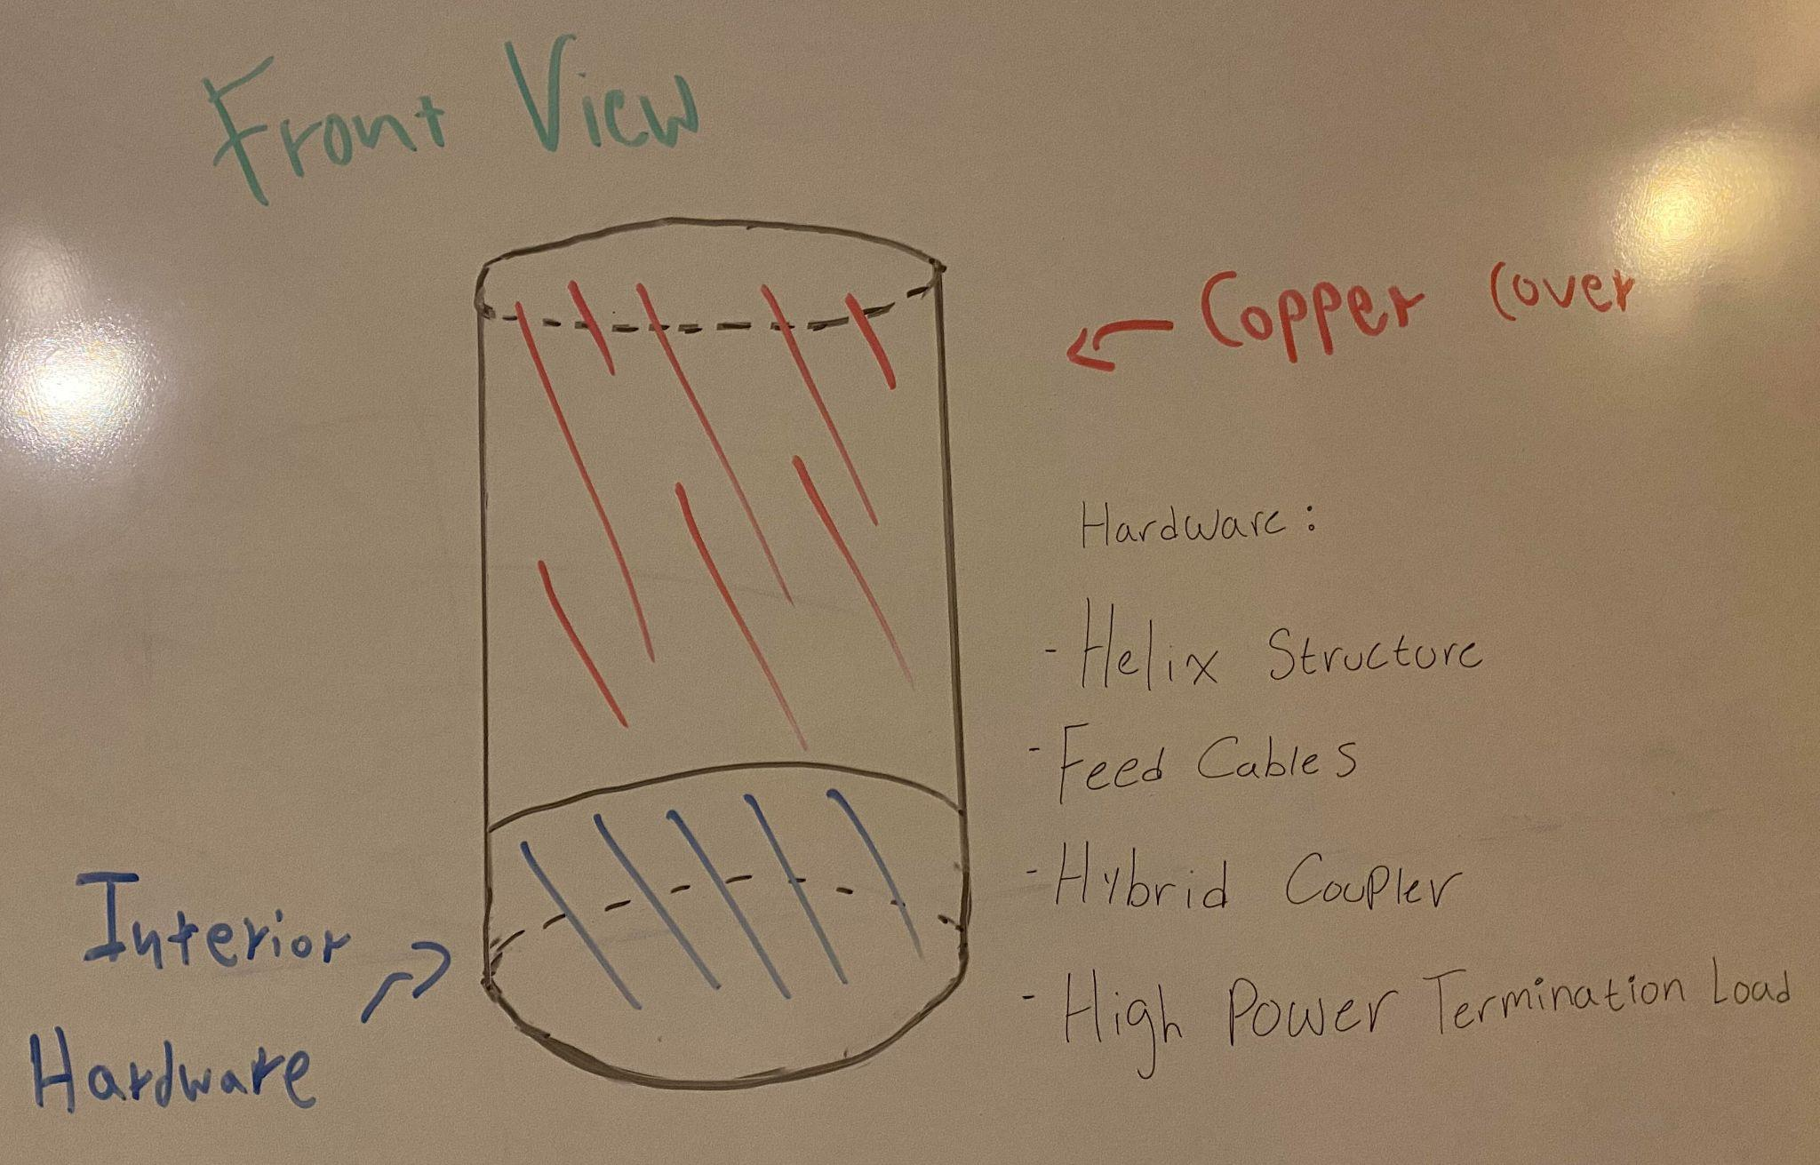

## 2.3 EVOLUTION OF PAYLOAD & SCIENCE INSTRUMENTS

**Iteration 1:**

* **NEW Instrumentation - Radiation**: Ionizing Radiation measuring instrument, Non-Ionizing Radiation measuring instrument, Neutron Radiation measuring instrument.
* **NEW Instrumentation - Temperature**: A simple thermometer capable of recording temperatures on mars.
* **NEW Instrumentation - Structural Integrity**: Spectrometer capable of measuring and identifying silicon dioxide (SiO2) and aluminum oxide (Al2O3). Also a seismograph to examine the structure of the cave walls.
  + **Issues**: A seismograph may not be the appropriate instrument for this. In the past, seismographs used by other Mars rovers are quite large and would claim much of the vehicle’s allowed mass.

**Iteration 2:**

* **Instrumentation - Radiation**: Ionizing Radiation measuring instrument, Non-Ionizing Radiation measuring instrument, Neutron Radiation measuring instrument.
  + **Issues**: This is a lot of equipment capable of taking up a majority of allocated mass. Neutron Radiation measuring instruments on the market tend to be quite heavy in particular.
* **Instrumentation - Temperature**: A simple thermometer capable of recording temperatures on mars.
  + **Issues**: There may be more advanced instruments available to accomplish this task.
* **EDITED Instrumentation - Structural Integrity**: Spectrometer capable of measuring and identifying silicon dioxide (SiO2) and aluminum oxide (Al2O3).

**Iteration 3:**

* **NEW Instrumentation - Radiation**: Radiation Assessment Detector (RAD). RAD can measure all types of radiation and is proven to be useful already; it is used on the Mars Curiosity Rover.
* **NEW Instrumentation - Temperature**: Thermographic camera. A thermographic camera will help visually represent the temperature of the cave. Will not be significantly heavier than a thermometer, but provides more data.
* **Instrumentation - Structural Integrity**: Spectrometer capable of measuring and identifying silicon dioxide (SiO2) and aluminum oxide (Al2O3).
  + **Issues**: Although visual data will be obtained with the thermographic camera, that data alone would not create a detailed map of the cave.

**Iteration 4:**

* **Instrumentation - Radiation**: Radiation Assessment Detector (RAD). RAD can measure all types of radiation and is proven to be useful already; it is used on the Mars Curiosity Rover.
* **Instrumentation - Temperature**: Thermographic camera. A thermographic camera will help visually represent the temperature of the cave. Will not be significantly heavier than a thermometer, but provides more data.
  + **Issues**: A thermographic camera has not been used on Mars before. It is unknown if the images produced would provide enough differentiation between low temperatures (below -100°C)
* **NEW Instrumentation - Structural Integrity**: Mössbauer Spectrometer. This measures the makeup and quantity of iron-containing minerals in rock and regolith. This is interesting, as it can measure the iron contents of the cave walls. The instrument has been proven useful; it is used on the Mars Spirit and Mars Opportunity Rovers. It is also very small.
  + **Issues**: Although this instrument is proven usable on Mars, there may be other instrument choices that can examine a wider range of molecules (molecules other than those only containing iron).
* **NEW Instrumentation - Structural Integrity**: LiDAR Scanner. Not only a way for the vehicle to navigate the cave, but the image data can also be saved and used to create a detailed 3D map of the cave.

**Iteration 5** (Final)**:**

* **Instrumentation - Radiation**: Radiation Assessment Detector (RAD). RAD can measure all types of radiation and is proven to be useful already; it is used on the Mars Curiosity Rover.
* **Instrumentation - Structural Integrity:** LiDAR. Not only a way for the vehicle to navigate the cave, but the LiDAR data can also be saved and used to create a detailed 3D map of the cave.
* **EDITED Instrumentation - Structural Integrity**: Alpha Particle X-Ray Spectrometer (APXS). This instrument is determined to be a better instrument than the MB for this mission. APXS is still lightweight and can collect X-ray spectra from the elements sodium to yttrium.
* **EDITED Instrumentation - Temperature**: Rover Environmental Monitoring Station (REMS). This instrument will provide more data than a thermographic camera and has proven to be usable on Mars rovers.
* **NEW Instrumentation - Communications**: Remote communications nodes that create a mesh network between the rover and primary lander, allowing communications to continue without a tether.

# 

# SECTION 3 - Vehicle & System Design

## 

## 3.1 SELECTION, DESIGN, & VERIFICATION

### 3.1.1 SYSTEM OVERVIEW

The dimensions of the chassis are 1 m x 0.5 m x 0.5m. It features a 6-wheel mobility system, driven by motors at ends of the axles. The height of the chassis can be adjusted by the rotation of the axles. The concept has two stages. The lower stage stores the battery and the computer hardware electronics. The higher stage holds all of the science instrumentation and the other major subsystems including communications and thermal control. The spectrometer is held by an arm to extend the range of its abilities. It can rotate 360 degrees and is adjustable between 10-30cm.

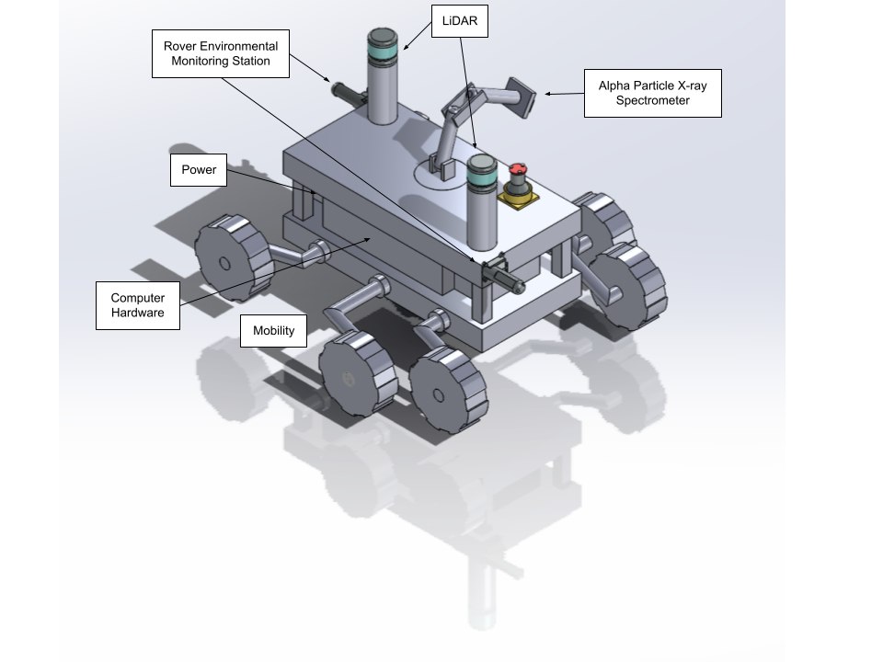

*Second Version Model*

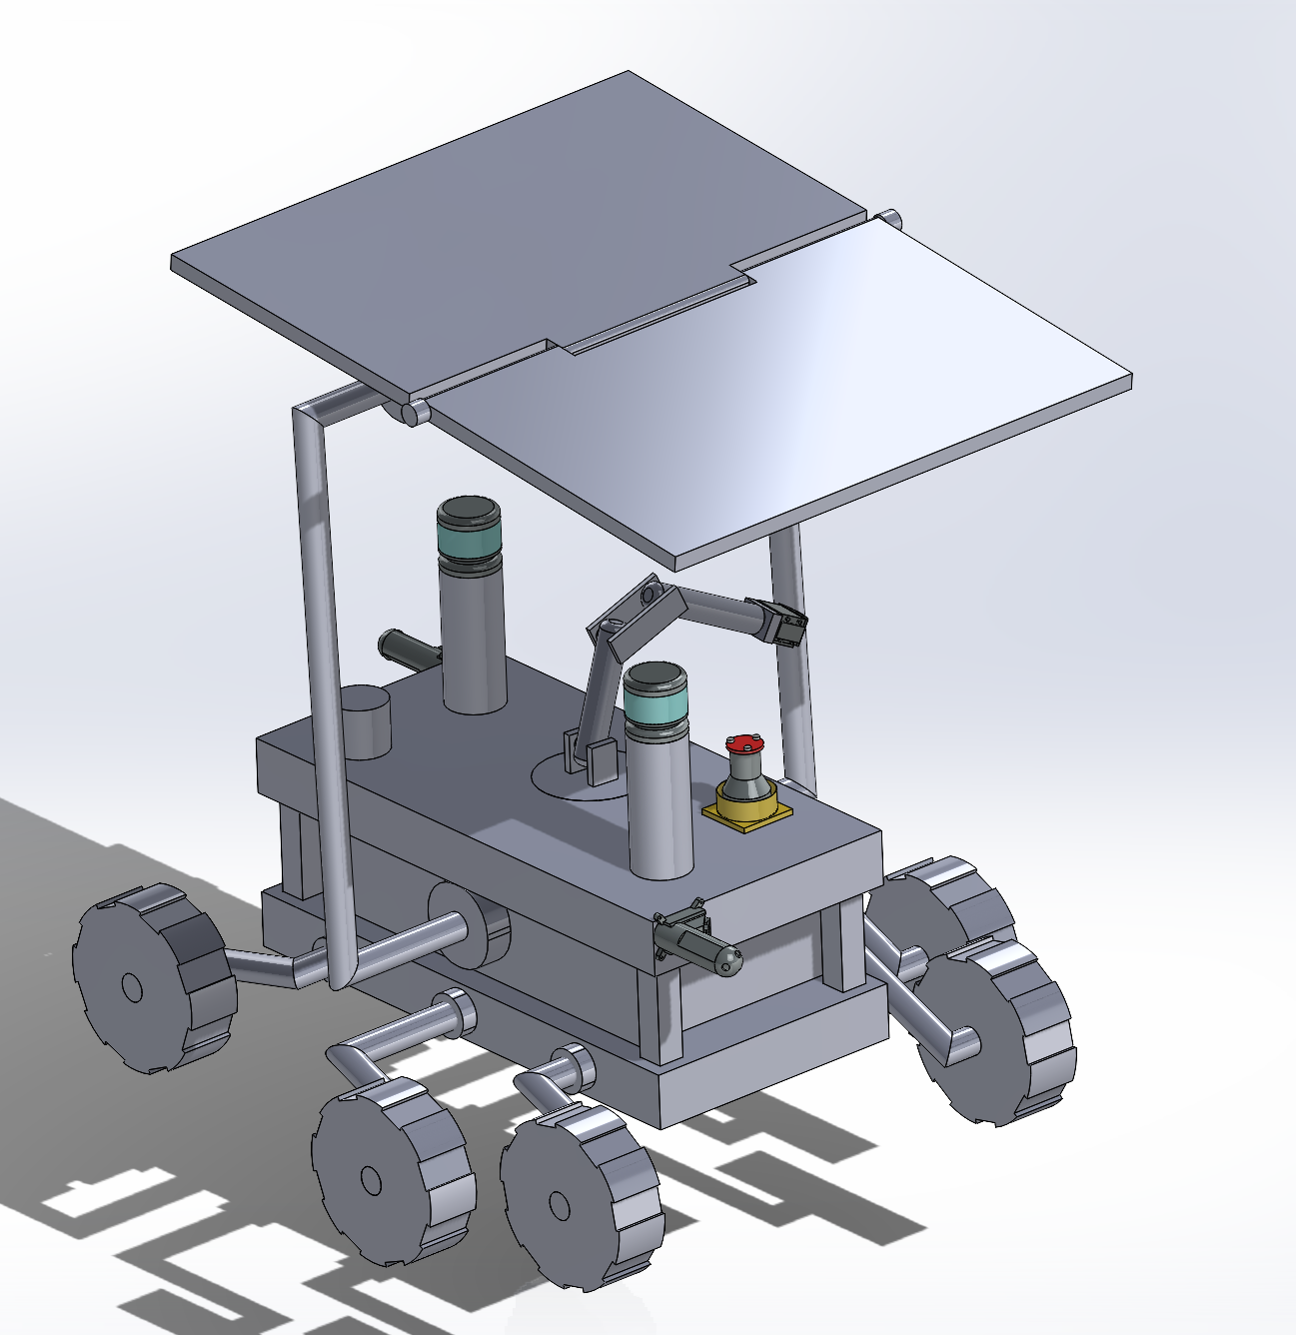

*Latest (third version) model*

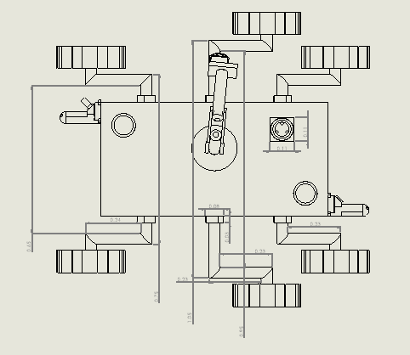

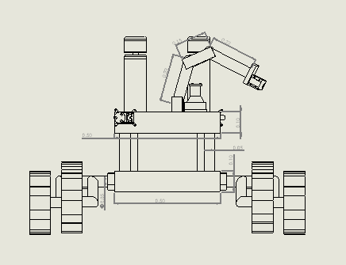

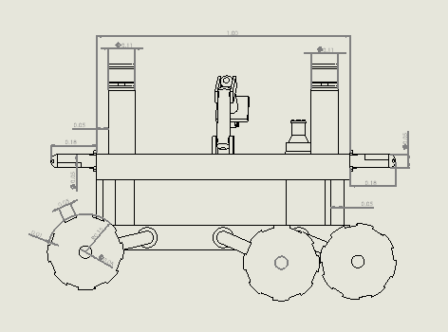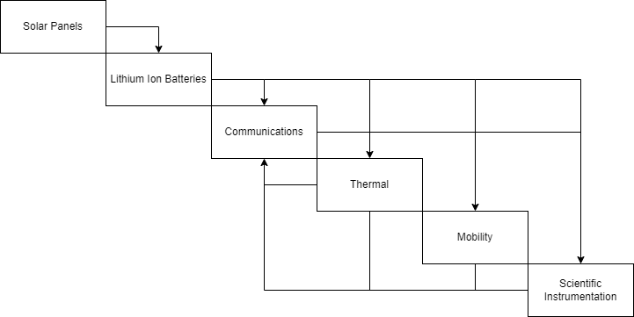

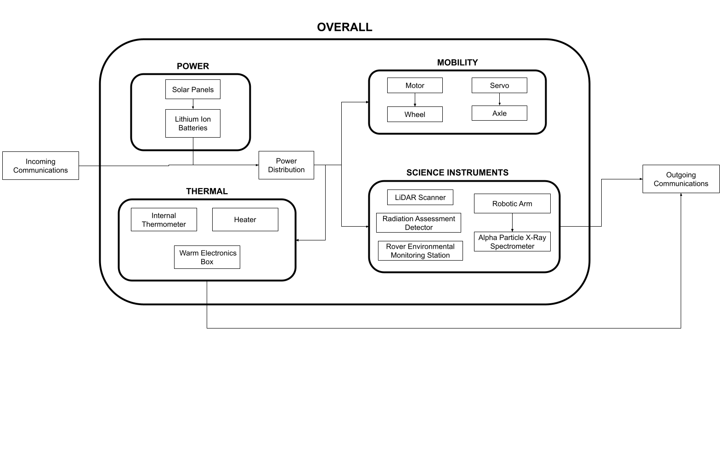

### 3.1.2 MECHANICAL SYSTEM OVERVIEW

**Requirements**

The mechanical system must weigh less than 30 kg and fit within a 1.5 x 1.5 x 1.5 meter box. The system shall support the weight of all subsystems and instruments. The chassis shall completely cover the power system from external debris and impacts. The system shall use wheels to traverse the cave terrain. The system shall place the communication nodes in an upright position.

**Overview**

The bottom and sides of the chassis will be a frame made from aluminum titanium alloy in order to support the instruments and equipment. All temperature sensitive equipment, along with the motor and circuitry will then be placed inside the chassis, surrounded by aerogel as insulation. Three axles will run horizontally across the center of mass which will support rotating legs with wheels at each end. The suspension system of these legs, inspired by the Perseverance rover, will effectively allow the rover to traverse any rough cave terrain while minimizing the risk for damage and allow it to travel up steeper inclines. While the wheels and legs in the corners will be powered by the motor, the center wheels will only provide stability as it traverses the cave.

The upper deck of the chassis will then contain the solar panels, communication, and instrumentation devices. At prespecified locations, two communication nodes, which will relay any radio signals being sent back to the primary lander, will lower out of the back of the rover through a remote locking mechanism. The nodes will be held at the bottom rear of the vehicle and the legs will rotate and lower the chassis so it is almost touching the ground. Then, one of the nodes will be released from a low height. The nodes will also have a base of 6 cm in diameter to ensure that they are stable in an upright position for optimal communication. These nodes are powered by their own battery systems and are rated to last around two weeks. The power source will also sit externally towards the back of the chassis and there will be a robotic arm with a spectrometer attached at the center. This robotic arm will contain two segments and two hinge joints with a rotating base. This setup will give the arm the flexibility to capture the majority of its environment with the spectrometer with a 360 degree view horizontally and 180 degrees vertically. Its entire range of freedom will be the shape of the upper half of a sphere.

At each location of interest, the spectrometer will capture its environment in its full range of motion with a predetermined set of movements. The arm will also be able to fold down onto the upper surface of the rover in order to save space. The dimensional footprint of the main chassis will be 1 x 0.5 x 0.25 meters.

**Manufacturing**

The use of Titanium Aluminum alloy as the material for the chassis will allow for a very light weight system with high resistance to erosion and a high tensile strength. Specifically, it will be made of Ti 6Al 4V, a two-phase alloy containing both alpha and beta phase crystalline structures. This alloy has a specific gravity of 4.42 and a tensile strength of 110 GPa, making it much lighter and much stronger than steel. It is also resistant to oxidation and corrosion. The alloy will be purchased from California Metal and Supply Inc and the chassis will be manufactured within a NASA facility by a team of engineers. Each piece of the chassis and mobility structures will be shaped and welded to form from sheets. Since this alloy has a high affinity for H2, N2, O2, and CO2 at high temperatures, a method known as Plasma Arc Welding will be used in order to avoid reactivity. The cutting of the sheet will be achieved using a 5-axis ZV 65/U600 EXTREME vertical CNC tool from Ibarmia. This will likely cost around $10 dollars for supply, equipment, and labor.

[Ti 6Al 4V product Data](https://www.spacematdb.com/spacemat/)

[California Metal and Supply Inc](https://californiametal.com/Titanium_6AL_4V_6_4_Sheet_Plate_Pipe_Tube_Rod_Bar.htm)

[Analysis of the Machining Process of Titanium Ti6Al-4V Parts Manufactured by Wire Arc Additive Manufacturing (WAAM)](https://www.ncbi.nlm.nih.gov/pmc/articles/PMC7040620/#:~:text=Regarding%20production%20costs%2C%20the%20buy,that%20gives%20its%20final%20geometry.)

**Verification and Validation**

We will not need more than the 0.09 x 36 x 96 inch plate of titanium alloy. Using the specific gravity of 4.42, we can calculate that the total mass of the chassis would be a maximum of 23 kg if we were to exhaust our supply, which is well under the requirement of less than 30 kg. The Chassis will be welded to form and after the build is complete we will validate that it remains under 30 kg and within a total volume of 1.5 x 1.5 x 1.5 meters.

In order to make sure that the chassis can withstand life threatening impacts, we will perform a series of static load tests upon completion. The maximum weight of the entire unit will not exceed 50 kg due to customer requirements, so an initial test will be performed to ensure that the chassis can hold an extra 30 kg of force while the legs are set to the lowest, highest, and a middle height. This process will then be repeated in 30 kg increments until a 300 kg mass is tested. Each test will measure the deformation of the material.

In order to ensure that the nodes can be placed in an upright position consistently, we will test the dropping mechanism 20 times for 5 different surfaces for a total of 100 times. Each surface will have varying smoothness so that we can ensure high success rate on uneven as well as flat terrain.

### 3.1.3 POWER SYSTEM OVERVIEW

In order to account for the challenges of operating in a low light environment, the rover will be powered by a 32V, 200Ah Lithium Nickel Manganese Cobalt Oxide (NMC) prismatic cell array that will in turn be charged by a 19401 cm2 solar panel.

Following deployment from the lander, the rover will unfurl its solar panels, entering a passive state wherein temperature and radiation will be logged near the cave entrance until the rover’s battery power supply is charged enough to support intermittent movement, and will charge for the duration of its surface tasks. After recharging, the Rover will activate and enter the cave, drawing power exclusively from its NMC cell until the end of its science mission.

**Charging Device**

The solar cell selected for this mission is a linear 19401 cm2 Metamorphic Multi-Junction GaInP/GaInAs/GE (IMM-α) solar array split into three parallel segments that run tangentially to each lidar mast. The cell itself boasts a 32% efficiency, and is paired with a MPPT equipped with a Buck configuration DC-DC converter to assure steady voltage production from the unit.

Prior studies of the photovoltaic system involving exposure to energy densities as high as 24 W/cm2 and as low as 0.1 W/cm2 project a power conversion efficiency rate of 32% under conditions with low aerosol optical depth at 25°C. [https://aip.scitation.org/doi/pdf/10.1063/1.2734507] Energy density on the Martian surface is determined by its incident intensity. Prior missions have determined this to be 590 W/m^2 on the Martian surface, which is effectively half of what it is on the Earth.

For the sake of inquiry, the upright, sun-facing surfaces of the array have a surface dimension of 150 cm^2, and occupy the top surface of the craft. Such a system can be expected to supply a maximum theoretical yield of 1144 W on Earth, or 198.6 W of energy on Mars assuming full sun use.

For a 32V battery connected to this system, there is a supply current of 6.21 amps. With a MPPT charge controller efficiency of 95% and expected system losses of about 20%, this becomes an effective rate of 4.72 amps using the following relation.

$Effective Current (Ah) =Supply Current∙(1-\%System Loss)∙\%MPPT Efficiency$

Lithium batteries have a charge efficiency of about 95%. For a 32V battery calibrated to be able to reliably power a system load of 700 W for 9 hours, a battery capacity of 196.9 Ah, or 207.2 Ah was found after factoring our depth of discharge by the following equation.

$Effective capacity (Ah) = \frac{Load *Duration}{emf voltage)}∙(\%charge efficiency)^{-1}$

Taking into account a typical absorption charging stage of 2 hours, we conclude that it can be expected to take 44 hours for the solar cell to charge the rover's battery to its effective capacity.

$Charging time (hrs) = \frac{Effective Capacity }{Effective Current}∙\%Depth of Discharge + 2$

The chosen source for the rover will be a parallel array of ten 32V, 20Ah Lithium Nickel Manganese Cobalt Oxide (NMC) prismatic cell batteries. Most modern Lithium-Ion batteries can be expected to drain 80-95% of its available energy during its normal course of operation. Based on this depth of discharge, it is recommended that each battery be rated for 700 Wh to ensure a maximum usable energy storage of 6.3 kWh.

[https://www.researchgate.net/profile/Kannan-Thirugnanam-2/publication/261076345_Mathematical_modeling_of_Li-ion_battery_for_chargedischarge_rate_and_capacity_fading_characteristics_using_genetic_algorithm_approach/links/54c9af6a0cf2807dcc27961e/Mathematical-modeling-of-Li-ion-battery-for-charge-discharge-rate-and-capacity-fading-characteristics-using-genetic-algorithm-approach.pdf?origin=publication_detail]

Per convention, the safe charging current must be kept to 30% of the battery's current rating. Maximum continuous discharge at any one time is going to be equivalent to the minimum kWh per day of the rover, calculated based on the wattage and runtime of all potential loads supported by the system. This is anticipated to be anywhere from .637 - .72 kWh. The battery is intended for daily cycling, and is sized in such a way as to ensure all systems can operate simultaneously for a total of nine hours. At an energy density of 150-220wh/kg, the fuel cell required to achieve this can be expected to weigh anywhere from 28.6 - 42 kg, depending on efficiency.

**POWER BUDGET**

The power consumption of the proposed rover is estimated to be the culmination of the demand for all subsystems and components.

**Hardware Power Draws**

The hardware system is combined by three components: the transceiver and antenna, the sensor, and the processors. The transceiver requires 65 W of power with 15 W of standby and 12.6 W of boot safe. This is the typical amount for a transceiver. The processors only require 10 W of power each, for a combined of 20 W. Lastly, the sensor requires 6 W to operate.

The RAD is a charged particle telescope made of three solid-state detectors and a cesium iodide calorimeter. It is a solid state detector with active coincidence logic to identify charged particles, aided with anti-coincidence logic to detect neutrons and x-rays. An energy input of 4.2W is needed to power this logic.

Source: <https://wrmiss.org/workshops/thirteenth/Hassler.pdf>

The LIDAR system used here is a Velodyne VLP-16 LiDAR PUCKTM. With a range of 100m the .813 kg VLP-16 makes use of a dual return feature to achieve a ~300,000 points/sec data collection rate. With a 360° horizontal FOV and vertical FOV pitch of ±15°, the sensor requires only ~8W to operate.

Source: <https://www.amtechs.co.jp/product/VLP-16-Puck.pdf>

The Alpha Particle X-Ray Spectrometer (AXPS) is an instrument payload configured as a single package consisting of a Silicon Drift Detector, two Printed Circuit Boards accommodating readout and control electronics, and a source holder assembly.

As this is a sensor whose operation time is limited, it is assumed that its energy consumption is around 4 W, which is the standard wattage of an x-ray spectrometer.

Source: <https://arxiv.org/ftp/arxiv/papers/1910/1910.09232>

The Rover Environmental Monitoring Station is an instrument designed to analyze the atmospheric pressure, temperature, humidity, winds, and UV radiation levels of the martian surface. With a standby power consumption rate of 402 mW. A Start-up idle rate of 4620 mW, a periodic ASIC heating consumption rate of 8744 mW, and a full operation consumption rate of 10082 mW, the instrument consumes a negligible amount of power compared to other critical systems.

Source: <https://link.springer.com/article/10.1007/s11214-012-9921-1>

LIDAR and movement are assumed to be simultaneously operated for purposes of estimation, And for a mobility system that can carry 50 kg on a 4wd system using a rocker bogie system, an estimated 248.38W will be needed to power the motors moving it.

**Heating System**

The primary objective of the heating system is to ensure the continued operation of the Rover in situations where significant variations in temperature present a risk to the mission. Using a Radioisotope Thermal Heater containing [amount] of Plutonium Oxide as a modeling basis, the rover utilizes a warm box body design that takes advantage of its chassis design to vent excess heat provided by the generator. In its design, it is intended to be capable of bringing the interior of the craft to zero degrees celsius in climates as warm as -40*c and as cold as -110c, if need be. To maintain this function, the ventilation and heat rejection system of the rover must be able to produce 45.5 J to 180.J minimum for surface operations. Provided a safety margin of 1.17 times operational effectiveness, we can expect for our heating elements to draw a range of 53W to 209W to meet this expectation.

[248.38 mobility system + 0.3*248.38 robotic arms + 65 W UHF + 9W AXPS+ 9 W REMS + 4.2W RAD + 10 W Processor +2*8 w lidar + 209 warm electric box]

In total, the lower bound of power draw for the system is approximately 645 W per hour of operation.

**VERIFICATION AND VALIDATION**

**Solar Cell Testing and Validation**

Solar Module Quality Assurance is done to ensure the use of the IMM-α PV array meets the standards set by the National Renewable Energy Laboratory (NREL). As per NREL standards, the focus of this testing involves the characterization of Spectral Responsivity, External Quantum Efficiency, and IV response in order to determine the overall efficiency of the cell. Using a monochromator to isolate em wavelengths produced by an ASTM E927 compliant solar simulator, a PV cell is exposed to a broadband inspection light source and a control/bias white light source to indicate how the solar cell responds at different wavelengths. From this data, comparisons to panels used in prior missions can be made to determine if the cell can be expected to work well in the Martian atmosphere. The use of the monitoring photodetector also provides analysts with a known optical load on the device, making it possible to measure the output current at each wavelength as well as the responsivity using the following relations.

[math detailing strategy of measuring responsivity]

From this, the external quantum efficiency of the cell can be determined using the following relation.

$EQE =\frac{hc}{qλ}R$

h = planck’s constant

c= speed of light

Q = electron charge

Lambda = light wavelength

R= responsivity

Using the same method, the total current and voltage under broadband light can be determined following the standard procedures outlined in IEC 60904-1 and ASTM E1036-15. The test of I-V response in the cell can be guaranteed to provide information on the Short-Circuit current(Isc), Open Circuit voltage (Voc), and the Current and Voltages at Maximum Power (Im; Vm). Again, a test sample is compared against a reference photovoltaic cell with known response calibrated under the same target spectrum, and polled for a spectral response matching within 5% of the reference cell.

A four wire measurement is used in measuring Vm across and Im through the device. With these, the efficiency can be defined and validated as the quotient of the Maximum Power Point and the Incident Power (Ps).

$N = \frac{I_{m}V_{m}}{P_{s}}$

Of particular importance to the mission is [determining whether Horizontal or Vertically crystallized IMM-α PV cells are best for the stated use case, and characterizing the qualities of each will be important in obtaining a power/weight ratio that can increase the feasibility of the mission.

**Power Supply Testing Procedures**

Testing and verification of the power supply primarily concerns the identification of various State of Health (SoH) indicators, such as Capacity, Internal Resistance, and Self Discharge, as well as the source’s behavior in storage, transport, and deployment. On account of the profile and nature of the mission, it is believed that testing will follow a similar pathway to those utilized in the 2003 Mars Exploration Rover Mission. A Rover Battery Assembly Unit (RBAU) constructed identically to the rover’s power source will be subjected to a battery of tests designed to characterize temperature, pressure, rad-hardiness, heat, and impact dependency of discharge capacity over the service life of the battery.

Standard Acceptance testing was performed prior to the main battery of tests to verify performance of the battery. This included measurement of isolation resistance, electrical continuity measurements, capacity determination tests at upper and lower bound temperatures, performing capacity stand tests at 72 hours OCV, verifying integrity of thermal hardware, and general visual inspections of RCV components. Capacity determination generally involves performing 2.5 cycles at 20°C and -20°C using a constant current charge rate of C/10 for 10 hours to fill the battery to a high SOC until a decay in supply current is noted. Following the decay, a constant current discharge would be induced until a known effective voltage reflecting 50% SOC was reached, and the process repeated for the number of remaining cycles at each temperature. Unlike deployment conditions, manual cell balancing is performed during ground testing to aid in the detection of battery faults, and any voltages that fall beyond prescribed safety limits are noted prior to an immediate termination of test.

Launch simulation can be achieved by discharging at a rate of ~C/2 to 50% VSOC  at 25°C after being charged to 95% VSOC. Cruise simulation is performed by draining it at a rate of exactly C/2 to 50% Vsoc at 25°C from a charge of 70% Vsoc . Cruise storage simulation, storing the battery at ~70% SOC for seven consecutive months, is aimed at addressing the risks of storing batteries at a high SOC as well as mitigating the severity of permanent capacity loss and impedance growth. Real-time observation of the Spirit and Opportunity missions suggests that, while long term storage at high SOCs poses a significant risk of cell dispersion and performance loss, these effects can be minimized with frequent rebalancing prior to arrival. The final load profile is the Entry, Descent, and Landing (EDL) Profile, wherein 50msec long 3C pulses of charge were applied to the 0°C battery under five different SOC profiles at .1 sec intervals. This “cold start ignition” test is meant to demonstrate the Li-ion’s ability to kickstart thermal systems on the rover upon arrival. Surface operations simulations involve performing ~50% DOD cycling in temperate ranges from -20°C - 0°C in periods lasting one Martian Sol (24.35 Earth hours). From surface performance evaluations provided by Spirit and Opportunity, a 93.3% - 92.8% capacity retention can be expected following the storage periods.

In each case, the batteries must be able to retain the ability to produce an output wattage needed for ground operations at the destination.

Sources:

<https://trs.jpl.nasa.gov/bitstream/handle/2014/39650/05-2158.pdf?sequence=1> <https://reader.elsevier.com/reader/sd/pii/S0026271418305687?token=006664D8EC32B478C8E5440EEC62999334F67C0C48CC792BC3FF0F9CD850A58134F522D47EE9F44E19E044D9F9510C7E&originRegion=us-east-1&originCreation=20220801175821>

**Power Use Chart**

To account for the low charge rate, the battery will be filled to and deployed at 95% of its maximum capacity to ensure a sustainable “per sol” discharge rate to extend the lifetime of the mission.Per the concept of operations, the rover will have four primary modes of operation, the details of which will be outlined in section 4.2.4, under “Mission Phases.” Immediate boot up activities will include a self test, wherein all systems are active for a period of one hour. During this time, metrics such as LIDAR Frame Rate data, RAD, AXPS, and REMS voltages, internal and external temperatures, and motor functionality are logged and transmitted to the lander for verification before the machine progresses to its initial mode of operation. Due to the data processing requirements for the AXPS, the craft will experience multiple 2-3 hr periods in a stationary state, leaving the RAD 750, the REMS, and the Warm Electric Box, as the only active systems during that time. While this would normally present an opportunity for charging, the passive rate of consumption from the warm electronic box alone would outstrip the rate of charge granted by the selected charging units. A fifth operation profile, called “Daytime Charging”, is intended to address this by turning off all systems save for the PLU long enough to charge the battery. The subsystem will be triggered only if the system’s temperature and battery level readings determine it is safe to do so, and will be aborted when a lower temperature threshold is crossed or when analysis time expires.

Following the completion of analysis, the rover will stand idle in a wait position, analyze temperature conditions, and toggle the WEB until enough energy to venture into the cave has been accumulated.

All simulations for the initial phase of the mission assumes the rover will deploy during the daytime/daybreak as a means of illustrating the anticipated energy use across the phase.

A significant risk of battery depletion exists with overnight operation of the drone during the overnight charging phase. Phase 1 Refractory Period Energy Use models show the breadth of possible states of charge for the battery following the completion of phase 1 operations, with the battery state of charge depicted both with and without the operation of the WEB in red and green, respectively. The latter models a scenario where weather conditions permit the omission of active heating, whereas the former reflects what is to be expected if the landing site temperature falls at or below -40°C, triggering operation of the WEB and forcing it into safe mode.

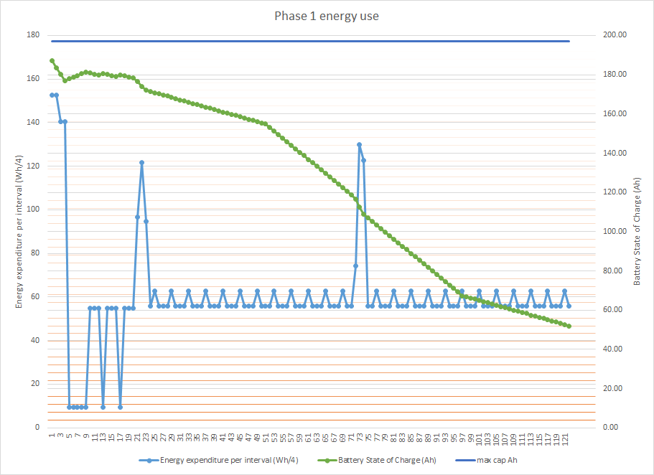

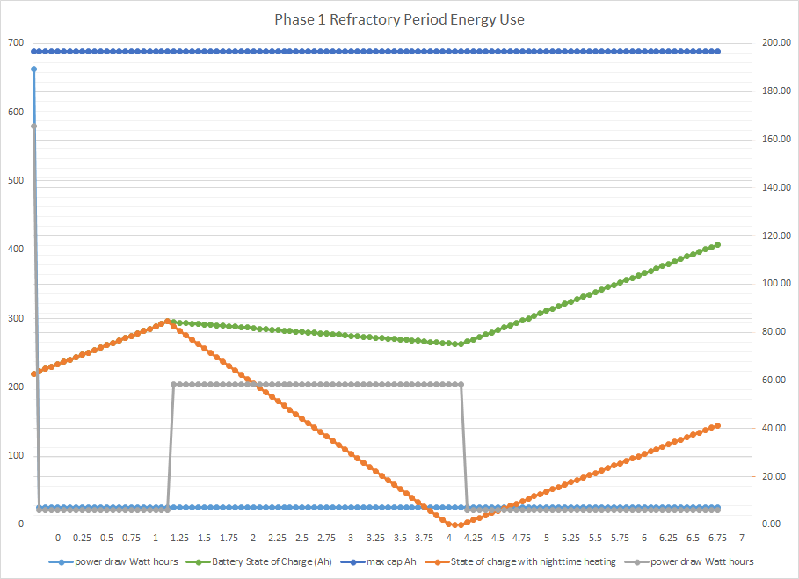

**Manufacturing and Integration**

PV Cell Manufacturing

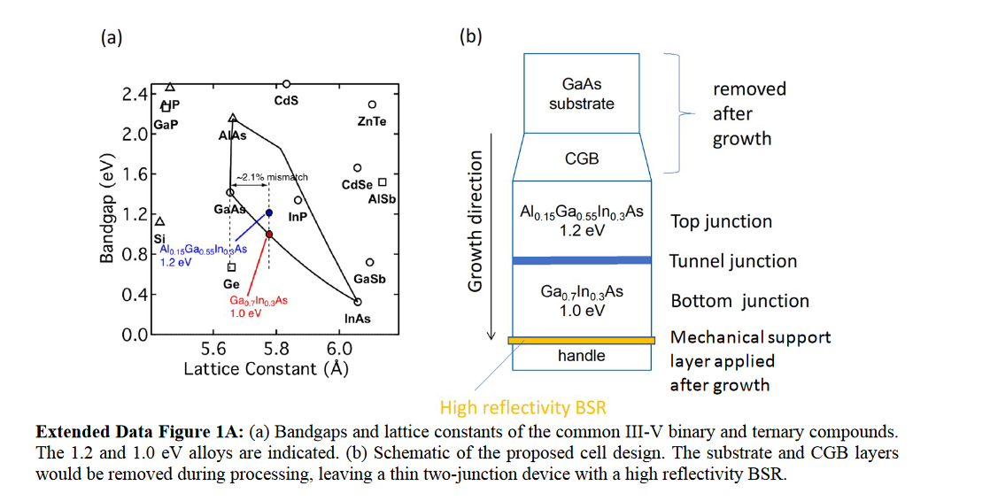

The GaInP2/InGaAs/Ge triple junction lattice matched solar cell is a commercially available photovoltaic cell with a performance of approximately 30% efficiency under 1 sun. Provided by multiple vendors on the market today, its performance in orbital energy harvesting regions grants it the reputation of being the primary source of space satellite power. Finding a reliable commercially available alternative is often difficult owing to the fact that higher efficiency cells often require either additional junctions or a more extensive degree of attenuation to the solar spectrum. In recent years, options for higher efficiency cells present themselves through the use of several different approaches, with the most notable successes being found in wafer bonding, dilute nitrides, upright metamorphic, and IMM; the last of which bearing an efficiency rating that merits consideration for the stated mission.

Inverted Metamorphic Multijunction Cells (IMM-α) manufacturing uses a Ga growth substrate to grow a top lattice matched high band gap InGaP and GaAs layer first, and then an underlayment of lattice mismatched InGaAs layers separated by Esaiki tunnel junctions. This procedure is then followed by the binding of a highly reflective back surface layer (BSR) to the underlayment before it is secured to a handling medium and “uncovered” with the removal of the substrate and CGB. The most prominent vendor for the IMM-α cell is SolAero Holdings, which was acquired by Rocket Lab in December of 2021. Electronic Supplementary Material published by the Royal Society of Chemistry concerning the resources needed to produce these cells anticipates a material cost ranging from $0.005/cm2 to $1.00/cm2.

Source: <https://www.rsc.org/suppdata/c8/ee/c8ee02341g/c8ee02341g1.pdf>

The solar panel array will be a linear array that occupies the top surface of the vehicle. The solar panel will be split into three segments: two segments running across the edge of the craft and one running down the middle. This design leaves space to accommodate the Iidar masts, the robotic arm, and the RAD sensor while being able to charge passively during operation.

**Fuel Cell Manufacturing**

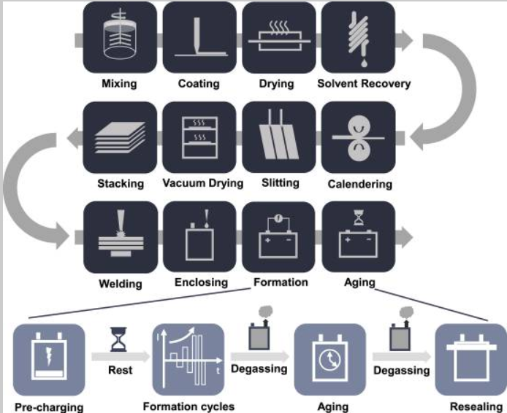

The manufacture of a lithium ion battery involves three major production steps: Electrode preparation, cell assembly, and battery electrochemistry activation. In the electrode preparation, an active material, a conductive additive, and a binder are mixed to form a uniform slurry with a solvent that varies depending on the component’s purpose. Slurry is then pumped into a slot die, and an aluminium or copper coating is applied on both sides of the current collector before the solvent is evaporated away. The finished electrodes are then stamped, slitted to required dimensions, calendared, welded, and enclosed before the cell can be activated. Electrochemistry steps are applied in the insertion of a Solid Electrolyte Interface layer, which is formed by charging cells to a low voltage, followed by a rest session to wet the electrolytes. The cells are charged and discharged at a low rate (C/20) before being gradually increased to ensure a stable SEI layer on the surface of the anode. During formation, cells are stored on aging shelves where gasses generated from the formation process are discharged for safety concerns. Several weeks later, the cells are sealed and stored once the final degassing step is completed.

Vendors with long-standing contracts with NASA, such as EaglePicher and [example], are anticipated to have the capability to produce a cell that meets the needs of the mission. Prior dealings suggest a time table of [time] for the production of such a device, but further investigation and assessment by said vendor(s) are needed to determine if such an estimate bears any merit.

Source: <https://www.researchgate.net/profile/Wayne-Cai/publication/267601746_Joining_Technologies_for_Automotive_Lithium-Ion_Battery_Manufacturing_A_Review/links/555e0ff608ae9963a1141014/Joining-Technologies-for-Automotive-Lithium-Ion-Battery-Manufacturing-A-Review.pdf>

### 

### 3.1.4 COMMUNICATIONS & DATA HANDLING SYSTEM OVERVIEW

**Requirements**

The requirements of the communication subsystem for the cave exploration mission are to always maintain communication with NASA scientists, and to process both input and output data. The communications system will have a combined mass of 3.5 kg, with a volume of 16.1 cm W x 20.3 cm D x 10.5 cm H for the transceiver and 267 mm H x 203.5 mm D for the RUHF antenna. The radio nodes will be 600 g each, with a combined weight of 1.2 kg and with dimensions of 10 cm D x 5 cm H. Additionally, there will be two RAD750 processors to fulfill the role of the Rover Computer Element for all the data processing. Lastly, a BOOSTXL-SENSOR will be used to navigate for its functions of a gyroscope and accelerometer. The accumulated cost of the subsystem adds up to $21.4 million USD for construction and operation.

**Overview**

The RUHF antenna will operate at a frequency of 435-450 MHz, with the ability to transmit 8 Mbps of data. The helix structure UHF antenna is composed by the interior helical antenna design, the feed cables for connecting the antenna with the transceiver, the hybrid coupler for its many needed functions, and the high-power termination block for switching wires. Additionally, the transceiver will be connected to the antenna for handling all the data and communication processing functions. Lastly, although not a direct component of the communication subsystem, two radio receiver nodes will be added to the mission for maintaining signal between the orbiters and the rover. The nodes will have an estimated range of 300-500 meters and will make it possible to maintain a signal up to two kilometers deep in the cave. The two RAD750 processes will act as the “brain” of the rover, by handling all the data records. They operate at 200 MHz frequencies and only one will be used at any given time, while the second processor will act as a backup in case of need. The processors are built to withstand both the temperature and radiation of Mars, as they have been used in previous rovers with impressive results. Each processor is built with 2 GB of flash memory, 256 MB of RAM, and 256 kB of ROM. Only the BOOSTXL-SENSOR will be installed on the rover for its many functionalities that cover all the rover’s navigational needs. The nodes will be placed originally on the back of the rover and will be dropped to designated spots to provide the best signal. The frequency will be the same as the antenna within the range of 435-450 MHz. The nodes will be deployed with a lock/drop mechanism on the back of the rover and will be able to remain online for up to two weeks (for more information, see Sections 3.1.2 and 3.2). The distance between the deployment of each node will be measured to ensure communication establishment. The nodes do not require to be visible with each other or the rover’s antenna, only to be within signal range. To ensure stability on the ground once deployed, the nodes have a circular base of 6 cm D that will prevent them from falling and sustaining any potential damage.

**Manufacturing**

The UHF antenna manufacturing will take place in Michoud Assembly Facility. Acquiring the hardware and the materials for assembling the antenna is not difficult. A small team of ten experienced engineers will be able to complete the job within a month of receiving the required components. The antenna is the cheaper part of the communication system, which will not exceed the cost of $1 million USD, including hardware and labor. The transceiver will need to be manufactured by a reputable contractor. Modern transceivers are difficult to build and program due to their multiple functions. Thus, L3 Harris will provide the transceiver for this mission. L3 Harris is a reputable contractor company with a wide range of prior completed space projects. There is a $20 million remaining budget for the communication system that will cover the purchase, as well as the operating cost of the mission. Like the transceiver, the radio nodes for the mission will also require a contractor company. It is not due to a complicated process, but it will be less expensive and time consuming than building them in a NASA facility. The nodes will not require more than a few thousand dollars to acquire, and once again L3 Harris is the choice for manufacturing them. Additionally, the processors will be bought directly from IBM, the original manufacturer, for $200 thousand USD each. Lastly, the BOOSTXL-SENSOR will be bought from TI for a cheap price of $1 thousand USD and it will be installed by the NASA engineers for the rover’s use.

**Verification**

One of the two processors along with the robotic arm will be tested by inputting direct data into the computer and analyzing the arm’s output. To verify both processors are functioning properly, the same test will be repeated. If only one processor works correctly, then the second processor will be replaced with a new one, and another testing cycle will take place. If neither of the processors work, then the fault must be with the arm, which will need to be reconfigured. The processors will also have to be tested for radiation resistance that will be met on Mars, as well as for the expected temperature range.

The transceiver and antenna will be tested in the Michoud facility to ensure that the components are compatible and that they have been correctly manufactured before attempting testing in a harsher environment. Just like the processors, both components will have to be tested for temperature and radiation resistance that match the expected conditions on Mars.

The sensor will be tested in an enclosed environment with obstacles placed around and ensure correct data read and navigation of the accelerometer and gyroscope. If the test fails another sensor will be requested and repeat the same process. Once again, the sensor, upon passing the initial tests, will have to be tested for radiation and temperature.

The nodes will be tested in an outdoor environment. The engineers will have to send signals to each node and verify correct transmission. The initial placement will be 100 meters and a test will take place for a growing distance of 100 meters per test. If either node fails, L3 Harris will have to provide a new one to match the expected requirements. Then a temperature and radiation test will take place.

**Validation**

Once the components pass their independent testing process, they will be assembled and tested in a cave system to validate the hardware. Signals will be sent to the rover and expect an output of recording the cave structure to verify direct communication is possible. While navigating the cave the BOOSTXL-SENSOR will be observed to ensure correct reading of the structure and the rover’s movement. While traveling deeper in the cave, the nodes will also be dropped to both test connection with each other and the rover, as well as test the rover’s distance from the surface capabilities. The cave system used for this test will have been studied beforehand, therefore the output data received from the processor and the arm will have to match the cave’s prerecorded results. If any of the hardware fails, due to their independent functions, it will be easy for the engineers to identify the problem and begin the debugging process. On the other hand, if the rover passes all the tests, and it maintains communication for more than 1.5 km deep in the cave, the subsystem will be ready for the Mars mission.

**RUHF Helical Antenna:**

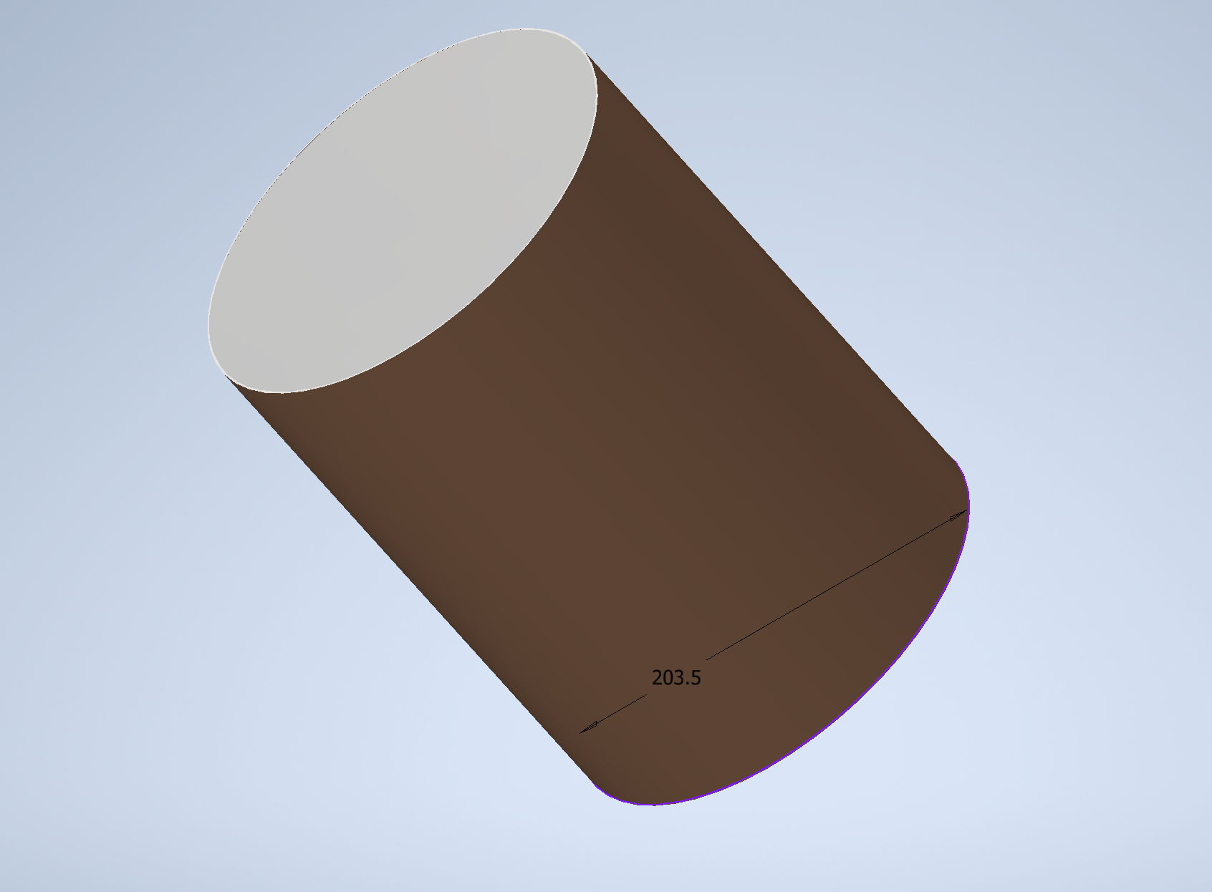

**RAD750 Processor:**

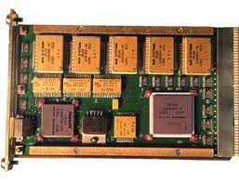

**Transceiver:**

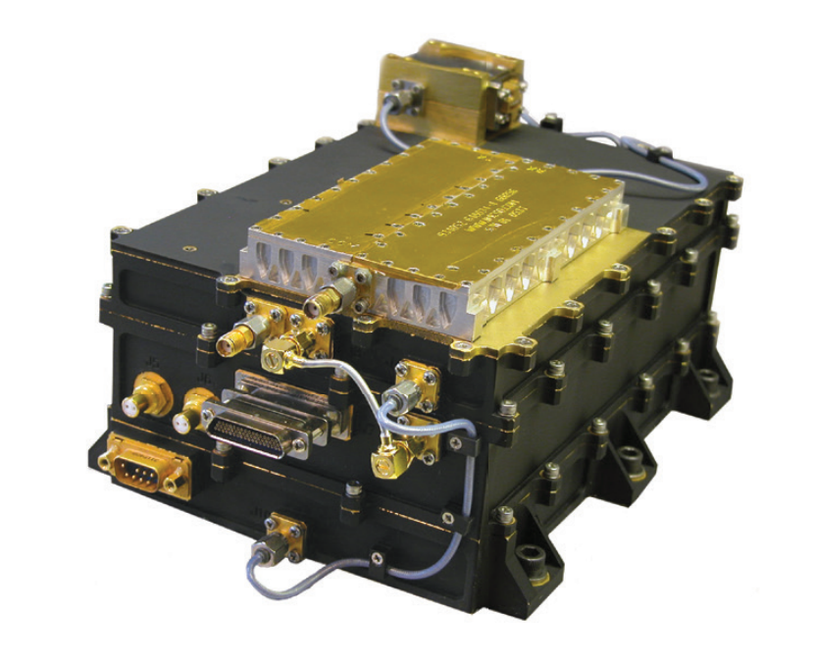

**BOOSTXL-SENSOR:**

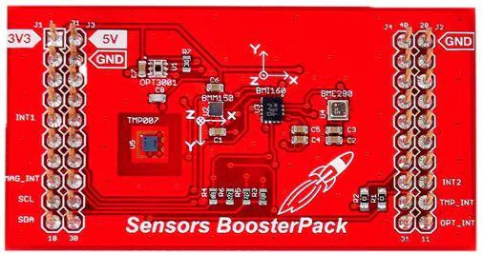

**Radio Node:**

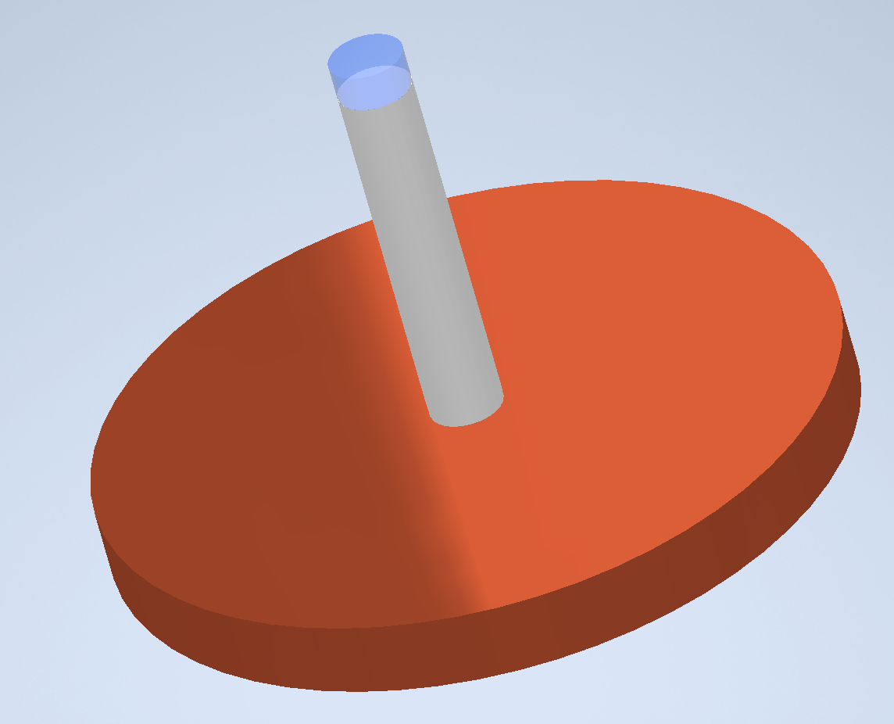

### 

### 3.1.5 THERMAL SYSTEM OVERVIEW

The thermal system is composed of the following: Thermostat, Radioisotope Heater Units, Aerogel, Multi-Level Insulation.

The expected thermal environment range is -103.8°C to 21.4°C. The thermal operating range of both payload and science instruments is -40°C to 40°C, however, the thermal system will maintain the vehicle’s body temperature at 0°C or 273.15K. To do so, the vehicle’s computer will make use of a thermostat to monitor the temperature inside the vehicle. If the thermostat detects the temperature inside the vehicle’s body is nearing -40°C, the computer will turn on the Radioisotope Heater Units to bring the temperature back to 0°C. On the other hand, in case the thermostat detects too much heat inside the vehicle’s body, the computer will shut down the heaters and non-essential electronics to let the inside cool down to the adequate temperature of 0°C. Solid Silica Aerogel will be used to insulate the inside of the vehicle’s body, to prevent heat from escaping. MLI will be used in the exterior of the vehicle as an additional insulated method.

Manufacturing of the Radioisotope Heater Units will take place at a NASA facility in conjunction with the United States Department of Energy. Thermostat, Multi-Level Insulation (MLI) and Solid Silica Aerogel will be purchased from contractors.

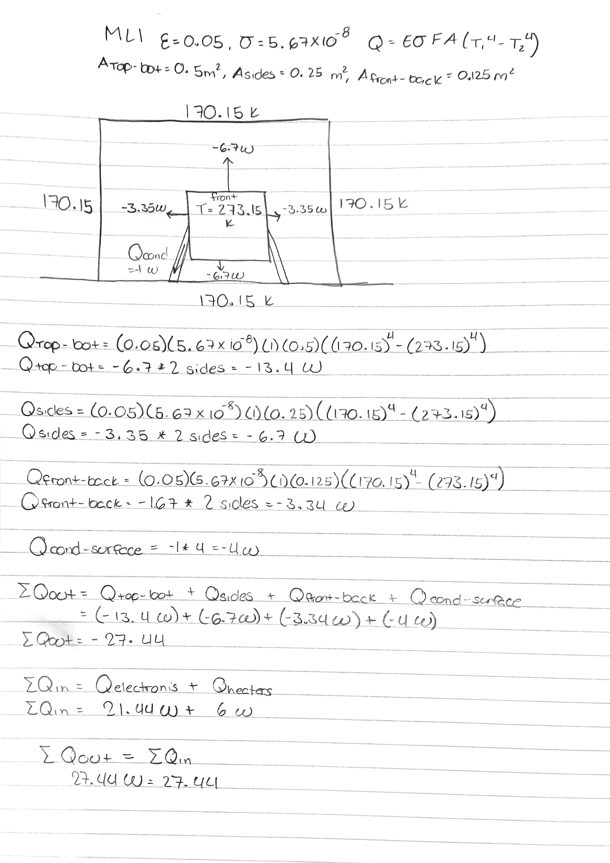

**Validation and Verification**

Vehicle’s thermal system shall be verified by testing. The test shall be conducted inside a temperature chamber at a NASA facility. The chamber shall simulate the expected minimum and maximum temperatures of the selected cave. The test shall be considered successful if the thermal system keeps the payload and science instrumentation at 0°C at all times.

### 

### 3.1.6 FMEA & RISK MITIGATION

The rover features multiple risk-mitigating design features that help keep the mission safe and successful. The chassis has been made with strong materials to prevent damage from any falls or collisions. All internal components are insulated and thermally controlled by the thermal management systems onboard. Internal components (computers, batteries, etc.) are placed in the middle of the rover to prevent the most valuable parts from being exposed to any physical damage risks. Cameras, sensors, and instruments that are along the outside of the rover are encased in strong housings that prevent damage in the event of any collisions with hard objects or rocks. Designing the system in this fashion keeps all scientific instruments within each other's vicinity for easy communication and protection from falls and other physical damage. A Failure Mode Effect and Analysis (FMEA) chart was created based on the current instrumentation and subsystems on the rover. It identifies priority risks, how these risks affect the mission, and proper responses/reactions that should be performed to minimize any damages to the project.

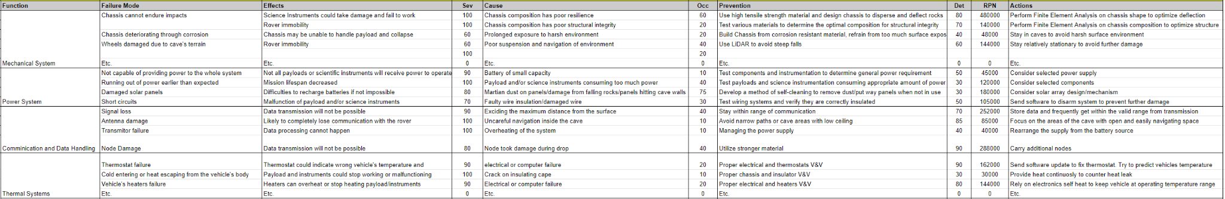





One of the more significant risk-safety systems that has been implemented into this design is the inclusion of radio antenna “nodes” for communications back to the primary lander. This method of communications eliminates the need for a wired tether and gives the rover free range when roaming the cave. The rover features two battery-powered antenna nodes that can be dropped every 600-800 meters the rover travels into the cave. These nodes create a mesh network of radio communications, each receiving and relaying any messages they receive. Messages sent from the rover will travel through the nodes and make their way back to the primary lander. Mesh communications eliminate the need for tethers, give the rover free roaming range, and prevent the loss of communications from any interference inside the cave.

With these communication nodes, the largest risk is the possibility of them falling over and potentially being damaged. To help mitigate this risk, the rover will use its LiDAR data to analyze the environment around it and ensure the ground it stands on is level and stable. The rover will then remember the state of the environment it dropped the node in, therefore adjusting how far it will travel before dropping the next node or turning around. In the event of a communications loss, the rover will automatically retrace its steps until it can communicate with the network again. Dropping these nodes in relatively stable environments and changing its course in real-time will also improve its ability to communicate between the other systems in the network.

| **ID** | **Summary** | **L** | **C** | **Trend** | **Approach** | **Risk Statement** | **Status** |
| --- | --- | --- | --- | --- | --- | --- | --- |
| 1 | Allocation of Equipment Failure | 2 | 2 | ↓ | M | Given the size and weight requirements for the vehicle, there is a risk that not all components and instrumentation of the vehicle will have enough space. | The current design of the project falls within size requirements, additional components will be added to the final design. Weight requirements must continue to be taken into consideration. |
| 2 | Power Outage within the spacecraft | 1 | 4 | ↓ | W | There is a possibility that there is varying or no power at all for the instruments and the spacecraft. | The current design and deployment plan allow for the project to meet requirements. |
| 3 | Collision of Rocks or Debris | 2 | 1 | ↓ | W | The rocks and debris inside the cave might interact with the movement and damage the rover. | A combination of aluminum alloys and titanium has been chosen for the primary project material. Components must continue to be taken into consideration. |
| 4 | Communication Loss | 2 | 4 | ↓ | W | The communication of the vehicle and the spacecraft may be lost while exploration. | Radio receiving nodes have been added to the mission to allow for an estimated range of 600-800 meters, and a depth of up to 200 meters below the surface. |
| 5 | Failure to enter inside a cave | 2 | 5 | ↓ | M | Failure to enter the cave could result from an unforeseeable event such as a sandstorm. The vehicle may need to enter a different nearby cave instead. | The landing site candidates have multiple nearby cave openings that are within 50 meters apart. |
| 6 | Instrumentation failure during the mission | 1 | 5 | → | R | Instrument failure could result in the failure of completing a specific task. | No Change |
| 7 | Rover fails to identify path while traversing inside of cave | 3 | 4 | NEW | R | Failure to identify obstacles or ledges could result in the vehicle flipping or becoming lodged. | No Change |
| 8 | Pointed/Loose Rocks | 2 | 3 | NEW | R | Pointed rocks can cause permanent damage to the rover tires. Loose rocks can become wedged into crevices of a mechanism. | No Change |
| 9 | Dust Storms at Cave Entrance | 3 | 2 | NEW | R | Dust storm at the entrance of the cave can prevent the solar arrays from fully charging the power cells. | No Change |
| 10 | Temperature change within cave | 3 | 3 | NEW | R | A drastic change in temperature can cause subsystems to malfunction and/or become obsolete. | No Change |

After studying and determining the possible risks, a mitigation matrix was composed, as shown below. It should be noted that the trend reflects the current state of the risk assessment.

|  |  |  |  |  |  |  |  |
| --- | --- | --- | --- | --- | --- | --- | --- |
|  | **LIKELIHOOD** | **5** |  |  |  |  |  |
|  | **4** |  |  |  |  |  |
|  | **3** |  | **9** | **10** | **7** |  |
|  | **2** | **3↓** | **1↓** | **8** | **4↓** | ming |
|  | **1** |  |  |  | **2↓** | **5↓ 6→** |
|  |  |  | **1** | **2** | **3** | **4** | **5** |
|  |  |  | **CONSEQUENCES** | | | | |

### 

### 3.1.7 PERFORMANCE CHARACTERISTICS & PREDICTIONS

Once all the subsystems pass the validation and verification process, the rover can be assembled and prepared for the exploration mission. The ideal season for the mission would be summer. Mars has a harsh environment, with temperatures reaching -220°F during winter but only +70°F during summer. To avoid the harsh cold weather that could possibly damage the battery, or cause mobility issues, the mission will happen during a Martian summer. The expected temperature range is between -100°F to +70°F, which is within the rover’s operational capabilities. Inside the cave, the mission would expect an even warmer environment of up to +30°F. That outcome would place the rover in an even more comfortable environment, for it to operate. Overcoming the possible difficult temperatures by planning the mission’s timing correctly, the rover is anticipated to function at its full potential and recover all the information that it is expected to. The subsystems have already been designed to deal with a degree of a possibly difficult environment, but if a more difficult situation arises that has not been expected, the rover will be directed to take shelter in the most ideal area inside the cave, until the conditions are more mild, thus resuming the exploration.

The design of the rover was chosen to ensure operation on difficult terrain without jeopardizing the mission. The rover will be built with a hardened shell that makes the vehicle more resilient to damage from the weather or small rocks from within the cave. Furthermore, the tire design was specifically to target the uneven terrain inside the cave, therefore preventing any mobility issues and overcoming any unexpected difficulties.

### 

### 3.1.8 CONFIDENCE & MATURITY OF DESIGN

The design of this mission has taken notes from other successful Mars missions to keep risk as minimal as possible. With this mission being exploratory, there are multiple unknowns regarding what the rover will face once inside the cave. To help alleviate as many of these unknowns as possible, the rover has been designed in a way that can be trusted and will perform as intended.

Most subsystems have been inspired by the Perseverance rover currently on Mars. In particular, the mobility and chassis most resemble Perseverance, albeit in a smaller form. Using designs already proven successful on Mars gives this mission a good eye in terms of confidence and maturity. Both the chassis and mobility subsystems carry TRL levels between 6 and 7.

The thermal, power and communications subsystems also take notes from Perseverance, Curiosity, and Spirit, but have less in common due to the constraints of the smaller form factor. These technologies, while tested in various industries on Earth, do not have as much experience in the space environment. While the engineers on this team are confident in its ability to perform well even in the harshest of environments, there is little real world proof of it thus far. These subsystems currently carry TRL scores between 4 and 5. More testing will be required as this mission is developed to raise the scores of these subsystems.

Overall, the systems being used on this rover are well suited for the exploratory nature of this mission. More testing will be required during system development to further ensure the success of the mission.

## 

## 3.2 RECOVERY/REDUNDANCY SYSTEM

There are multiple redundancy and recovery systems that have been implemented to prevent a mission failure from damage to the rover or its components. The largest area of concern for this mission is the rover's ability to move on the Martian surface. There are a few ways to recover from a “fall” or “trip” on the surface - the chassis features a reinforced steel frame and large suspensions in the wheels to absorb shock from a fall while maintaining its original shape. If the rover senses a fall or other sudden movement with the onboard accelerometer and gyroscope, it can move its sensitive instruments closer to the center of mass to help shield itself from fall damage. The frame is designed to take a hit, but the instruments are not. In the event of a “trip” (tipping over), the rover can perform a similar maneuver before hitting the ground, but can also use its heavy-duty wheels and robotic arm to help itself stand back up.

The next most important system is communications. Keeping a healthy communication with the primary lander and orbiter is essential in determining the success of this mission. To prevent communication loss, radio nodes will be placed in the cave every 600-800m of travel. These nodes create a mesh network inside the cave, allowing radio communications to continue without a tether or power-hungry radio attached to the rover. These nodes feature antennas that can send data farther than the radius we will place them at, so communications can continue between nodes even if one fails. If all radio communication is lost, the rover will retrace its steps to the opening of the cave and send any data it has collected before trying again in timed intervals.

Should any subsystems or instruments fail on the rover, the onboard computer can attempt to run hardware diagnostics or power cycles on individual pieces of equipment. If an instrument is physically damaged and is deemed unfixable, that portion of the mission will have to be retired. Physical damage is a risk associated with any exploratory space mission but, due to the low-cost, smaller nature of this mission in particular, there is less room (physically and financially) to prepare for those uncertain events. Because of this, more time has been spent designing a reinforced chassis and choosing strong materials that are less likely to be damaged in any unlikely event such as falls or trips.

## 

## 3.3 PAYLOAD INTEGRATION

All of the instrumentation, as shown in the images below, will be at the top stage of the rover. The radiation detector will be mounted towards the front of the concept. The spectrometer will be mounted on a robotic arm to maximize the range of data collection. The LiDAR scanners will be mounted to the top of cylinders to maximize Due to the risk of there being an obstruction, there are two LiDAR scanners to switch between. The LiDAR scanners are mounted at the front right and rear left. There are two REMS sensors that will be mounted on opposite sides. This is to maximize the exposure to the air, depending on the wind direction.

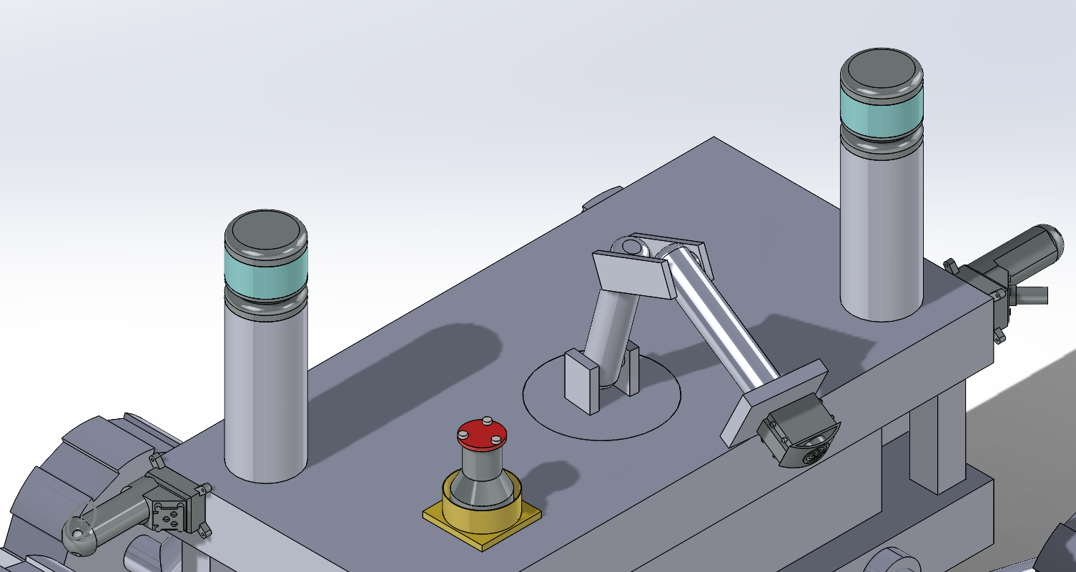

The APXS spectrometer utilizes an arm to extend its range. The base is 10 cm in diameter. It is able to rotate 360 degrees through a motor embedded in the second stage plate. Both of the legs utilized will be 20cm and the arm link will be 10cm. The plate that the APXS is mounted on will be 6cm x 4cm.

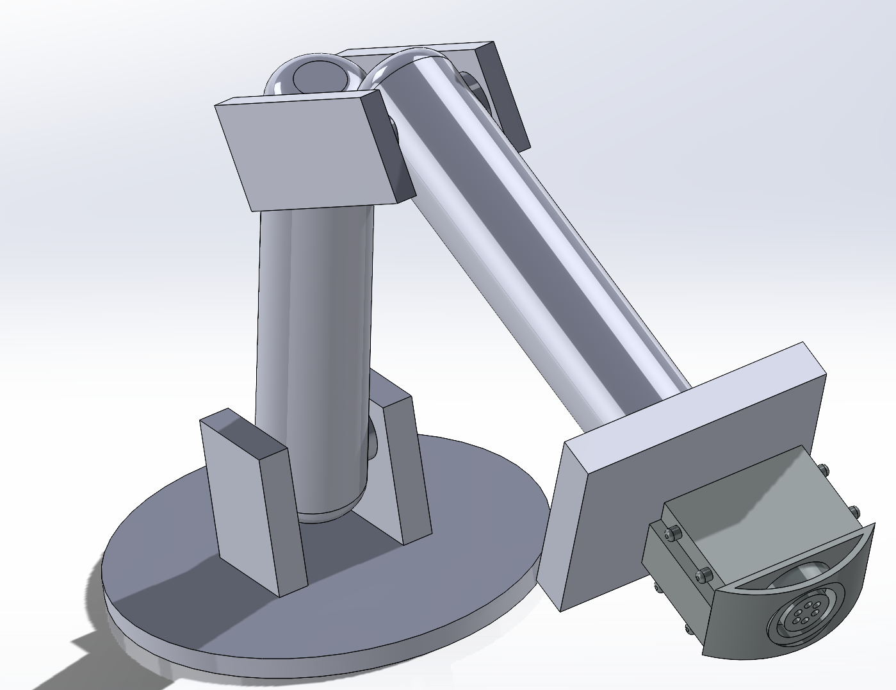

# SECTION 4 - Science Instrumentation

# 

## 4.1 SELECTION, DESIGN, & VERIFICATION

### 4.1.1 SYSTEM OVERVIEW

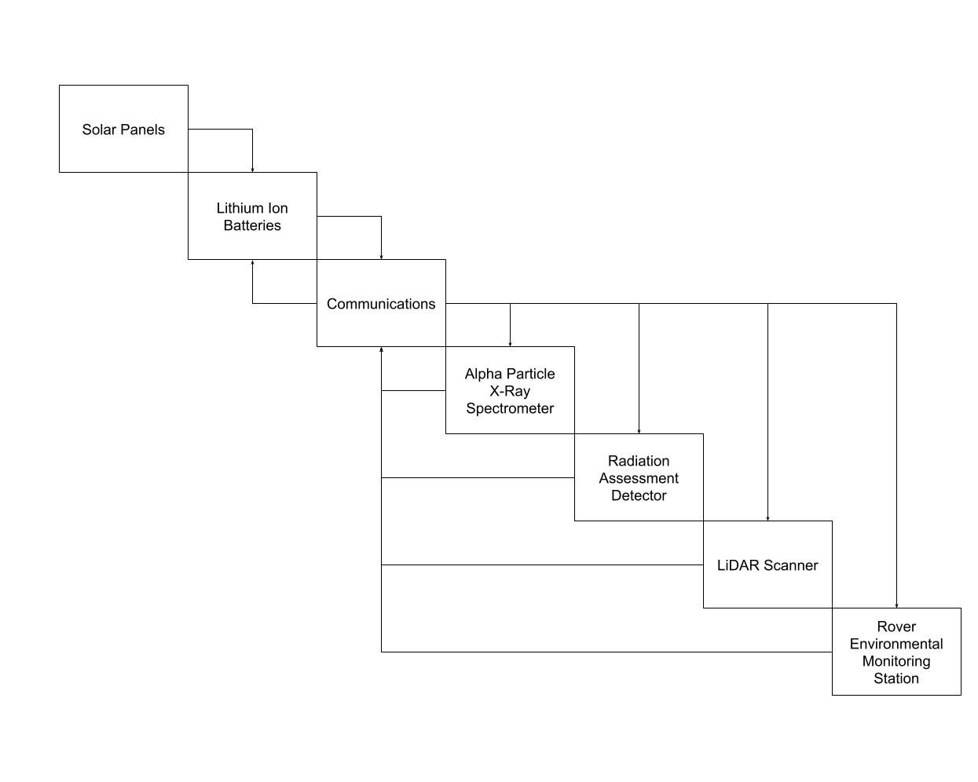

**Radiation Assessment Detector (RAD)**

* Collects data for 15 minutes every hour.
* Saves data to NVRAM (Non-volatile random access memory), up to 1023 packets (unable to find exactly how large a “packet” is in this context), until the data can be transmitted to a rover or satellite.
* Data must have a charge resolution of ±2 charge units for particles with energies above 500 MeV/n (Rios, *Calibration and readiness of the ISS-RAD charged particle detector - NASA*)

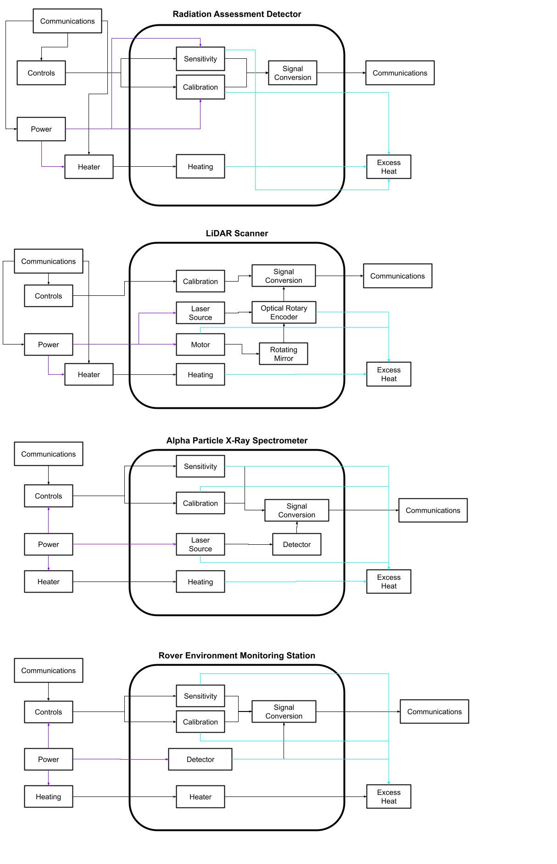

**LiDAR Sensor**

* Runs continuously during cave traversal.
* Saves data as a series of 3D coordinates (point cloud).
* The instrument successfully can see at least 10 meters and can avoid obstacles
* The instrument shall obtain a point cloud with a point-density of at least 20 points/m2

**

**Rover Environmental Monitoring Station (REMS)**

* Measurements are taken for five minutes every hour or on an on-demand basis. The data will be available as ASCII files that can be displayed on any platform with common software (Rodriguez-Manfredi, PDS: Data Set Information 2013).
* Data is stored in the internal memory of REMS – the data will be time ordered and mixed with the following data types:
  1. Sensor Acquisition
  2. Engineering
  3. Humidity Sensor Regeneration Acquisition
  4. Humidity Sensor Regeneration Report
  5. Humidity Sensor Defrost Acquisition
  6. Humidity Sensor Defrost Report
  7. Ground Temperature Sensor Calibration
  8. Reset
  9. Sleep
  10. Event Entry
  11. Ground Temperature Sensor Gain Management
  12. Error
* Ground Temperature Sensor (GTS) must be faced towards the ground and away from the rover.

**

**Alpha Particle X-Ray Spectrometer (APXS)**

* Data Collection: Data is stored in a 32 Kbyte SRAM (NASA, *PDS: Instrument Information*).

**

### 4.1.2 SUBSYSTEM OVERVIEW

**Radiation Assessment Detector (RAD)**

* Power Consumption: 4.2W
* Mass: 1.56 kg

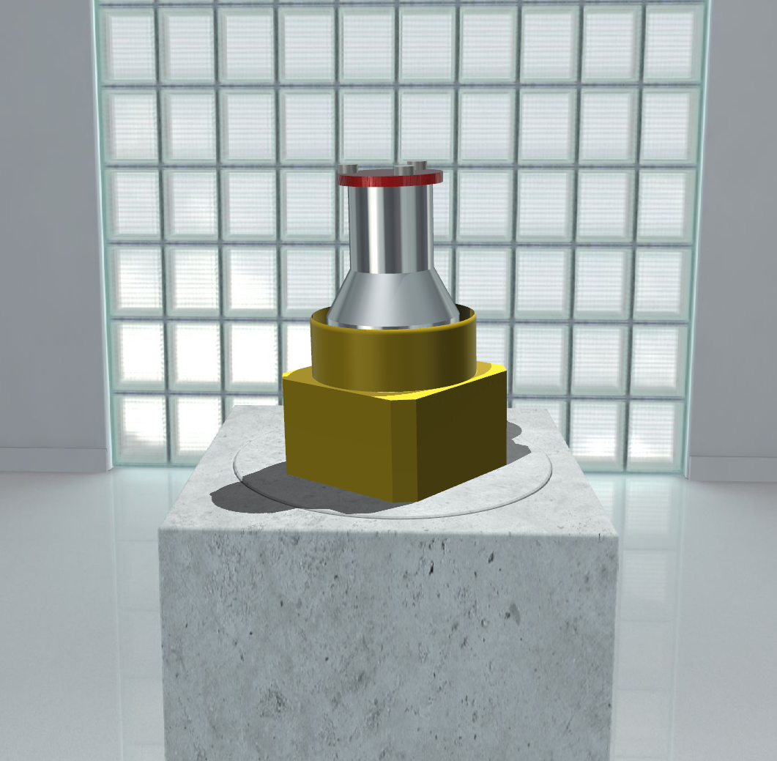

**LiDAR Sensor**

* Power Consumption: 8W
* Mass: 1 kg
* Operating Temperature Range (off-the-shelf): -20°C to +60°C

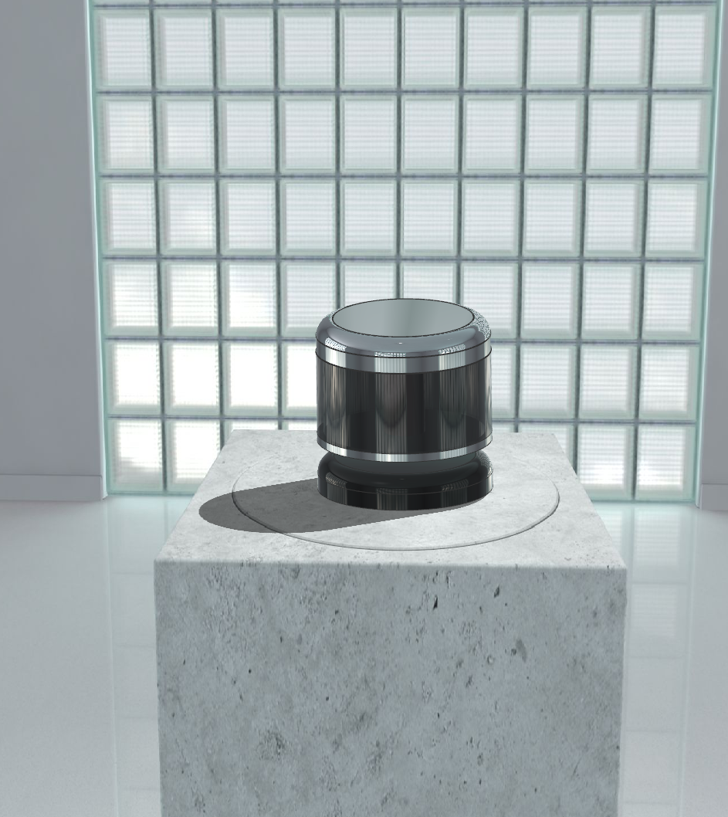

**Rover Environmental Monitoring Station (REMS)**

* Power Consumption: 4.0 W
* Mass: 1.3 kg
* Operating Temperature Range: -130°C to +70°C
* GTS is capable of detecting temperatures in the range of 160K to 305K with a precision of ±0.2K

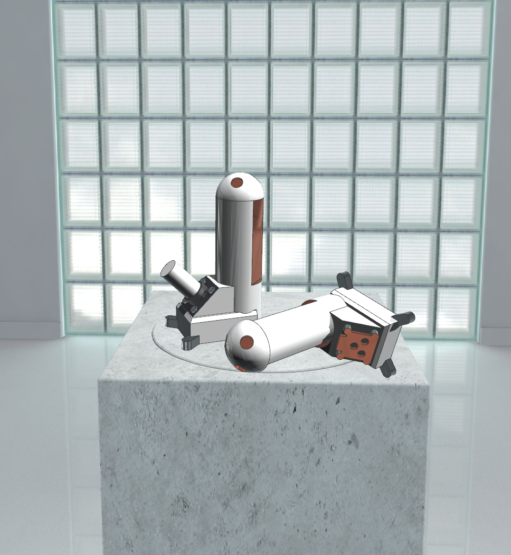

**Alpha Particle X-Ray Spectrometer (APXS)**

* Power Consumption: The interface for commanding the instrument and transfer of data consists of an RS 422 serial link. Power is provided to the instrument directly from the board battery (nominally 28V); voltages required by the electronics (5V digital, ±5V analog and ±12V analog) are generated by its own power converter and filters (NASA, *PDS:* *Instrument Information*). The average power consumption is 1.5W (Klingelhoefer, *Alpha Proton X-ray Spectrometer (APXS)*).
* Mass: 0.64 kg
* Operating Temperature Range: Rover interface and electronics circuits must be kept in the range of -50°C to +70°C and the detector shall be cooled to -35°C to maintain a resolution of 150eV at 5.9keV (Shanmugam et al., *APXS on board chandrayaan-2 Rover*, 2012).

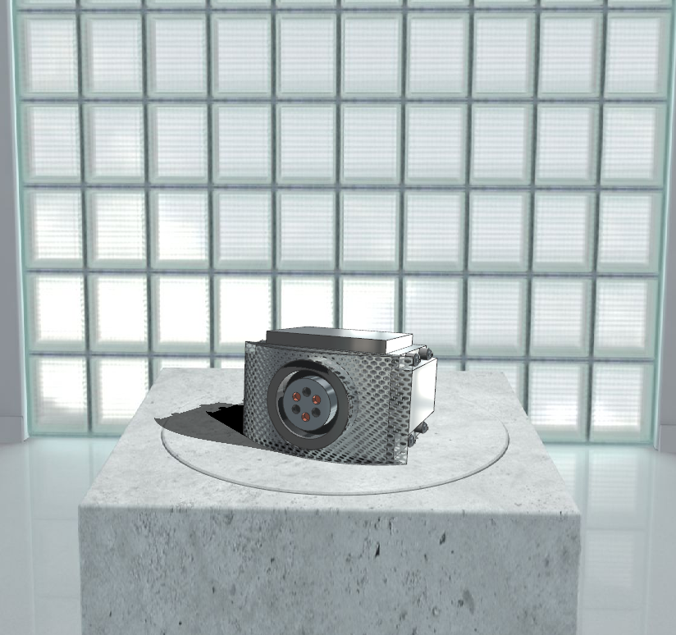

### 4.1.3 MANUFACTURING PLAN

The Radiation Assessment Detector (RAD), Rover Environmental Monitoring Station (REMS), and Alpha Particle X-Ray Spectrometer (APXS) will be manufactured at a NASA facility, while the LiDAR scanner will be purchased from different manufacturers. The LiDAR scanner will be manufactured by Valeo. The robotic arm that interfaces with the spectrometer will also be developed at a NASA facility. Once the instrumentation and accessories are available, it will be implemented with the overall concept at a NASA facility.

In accordance with the schedule, the LiDAR scanner will be purchased by the date of October 10, 2023. There will be a two-week margin to wait for delivery. Work on the Radiation Assessment Detector (RAD) and can begin during this time. The manufacturing period of the instruments will be one month. With a margin, the manufacturing of the RA.

### 4.1.4 VERIFICATION & VALIDATION PLAN

**General**

* Temperature testing in a lab facility at -250°F for 12 hours
* Temperature testing in lab facility at 70°F for 12 hours
* Extreme radiation testing in a lab facility at a level of 1 mSv (millisievert) for 12 hours

**Radiation Assessment Detector (RAD)**

* Radiation exposure testing in a lab
  + 1 mSv (millisievert) for 12 hours
  + Ensure that what the instrument is reading matches the testing environment readings

**LiDAR Scanner**

* Field testing in an Earth cave
  + Verify that the scanner is able see at least 10 meters ahead
  + Verify that the scanner is able to properly map its environment

**Alpha Particle X-Ray Spectrometer (APXS)**

* Vacuum chamber testing in a lab
* Verify that the spectrometer is able to emit Alpha Particles towards the geological sample
* Ensure that the instrument readings match the previous cross calibration results.

### 4.1.5 FMEA & RISK MITIGATION

Failure modes were between the 4 different instruments. Most of the issues had to do with inaccuracies in data and power failures. However, some instruments had specific issues. For example, the APXS uses an arm to extend the range of its abilities. If the arm were to fail in any way, the APXS would be hindered from collecting the full extent of data.

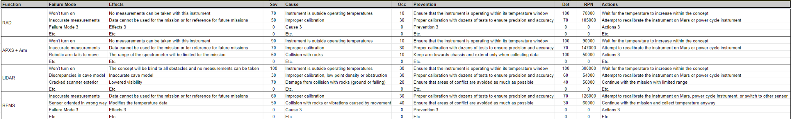

Although a lot of the failures have a high level of severity, the level of occurrence for most of the issues are low. The issues can be minimized by calibration, tests for repeatability, and by ensuring that the concept does not collide with obstacles while traversing the cave.



Using by multiplying the levels of severity, occurrence, and detection, the risk priority number was determined. The failure that has the highest priority is if the LiDAR does not turn on. Actions were also determined for cases when the issues occur during the mission. Since a lot of the issues are temperature and calibration sensitive, the solutions involve waiting.



Some risks from 3.1.6 carried over to this section due to some similarities in issues that can occur. Other issues included obstruction of the LiDAR scanner and inaccurate data from instruments. These risks have been addressed and are trending towards improvement.

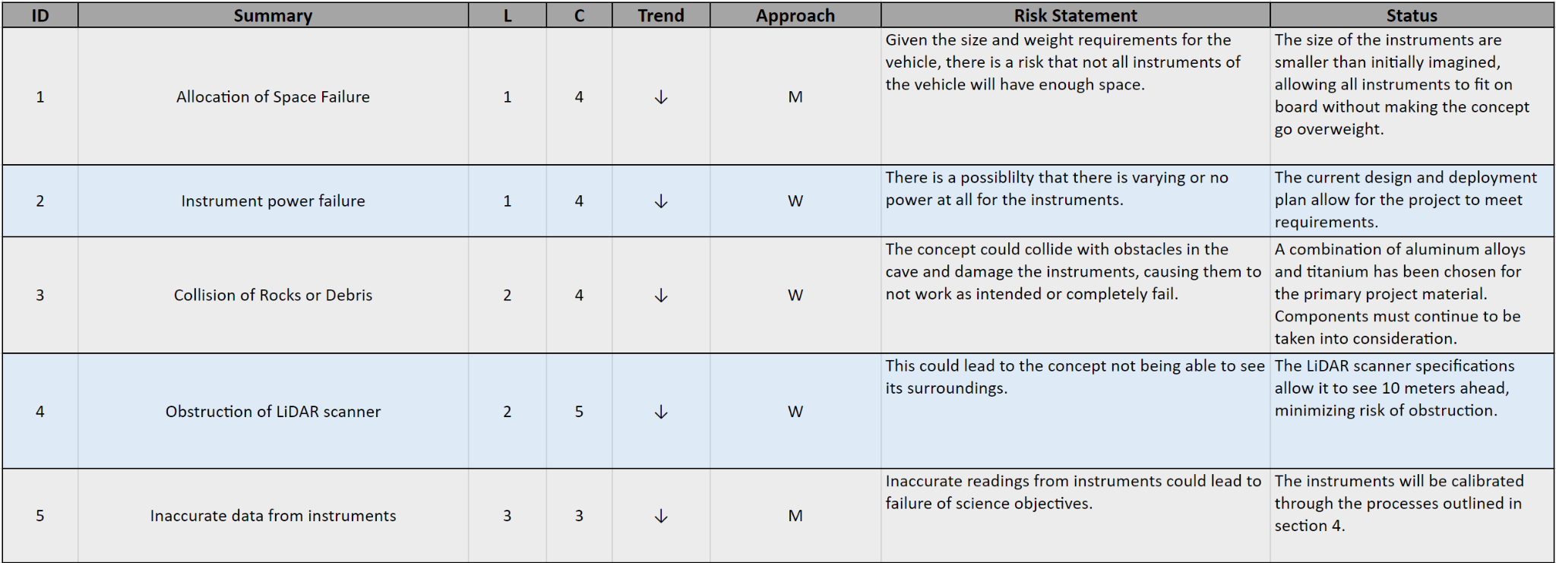

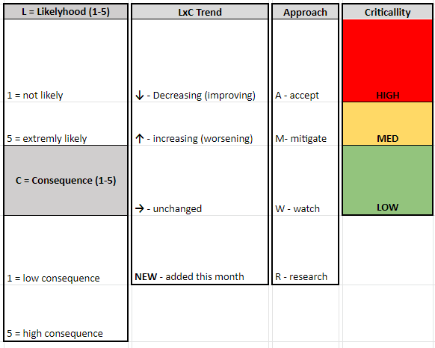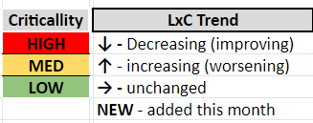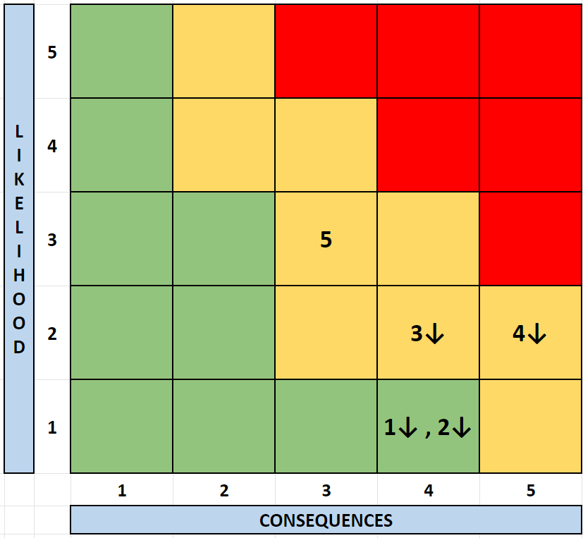

### 4.1.6 PERFORMANCE CHARACTERISTICS

The craft will arrive during Mars’ spring season; therefore, it is highly unlikely that the craft will face temperatures lower than -103°C (the lowest recorded temperature for the area) or temperatures higher than 21.3°C (the highest recorded temperature for the area). The Radiation Assessment Detector (RAD), Rover Environmental Station (REMS), and Alpha Particle X-Ray Spectrometer (APXS) have all been successfully used on previous NASA Mars Rovers, giving these instruments a Technology Readiness Level (TRL) of 9. The high TRL and testing facilities on Earth, provide high confidence that the RAD, REMS, and APXS will perform proficiently on this mission.

Unlike the three instruments mentioned previously, LiDAR has not been used on Mars before. However, LiDAR scanners have been used to map caves on Earth numerous times. The LiDAR scanner will be deployed to map three caves on Earth with a similar “outer” structure to the target cave on Mars – a lateral cave entrance. The LiDAR scanner will also be tested to ensure that it can operate in temperatures of -113°C to 31.3°C (the yearly minimum and maximum temperature of the surface around the cave ±10°C). With the on-Earth cave mapping tests and operating temperature tests, the LiDAR shall have a TRL of 6.

## 4.2 SCIENCE VALUE

### 4.2.1 SCIENCE PAYLOAD OBJECTIVES

The mission will collect data to describe the cave environment in three categories: ambient radiation, temperature, and cave structure. The Radiation Assessment Detector (RAD) will be used to measure ambient radiation - this will yield valuable data on the amount of radiation shielding the cave provides when compared to Mars’ surface environment. Temperature and air pressure data will be recorded with a Rover Environmental Monitoring Station (REMS) - this data can be compared to the temperature of Mars’ surface to determine how insulated the cave is. The cave’s physical structure will be examined with a LiDAR sensor; the sensor will produce a point cloud that can be converted into a detailed 3D image. The composition of the cave’s walls will be examined with an Alpha Particle X-ray Spectrometer (APXS) - this instrument will provide qualitative and quantitative data of elements present in the cave wall (from sodium to yttrium). These objectives will yield data that will be useful for more complex missions in the future; it is possible that Martian caves could house facilities for human habitation or simply for long-term equipment storage.

### 4.2.2 SCIENCE TRACEABILITY MATRIX

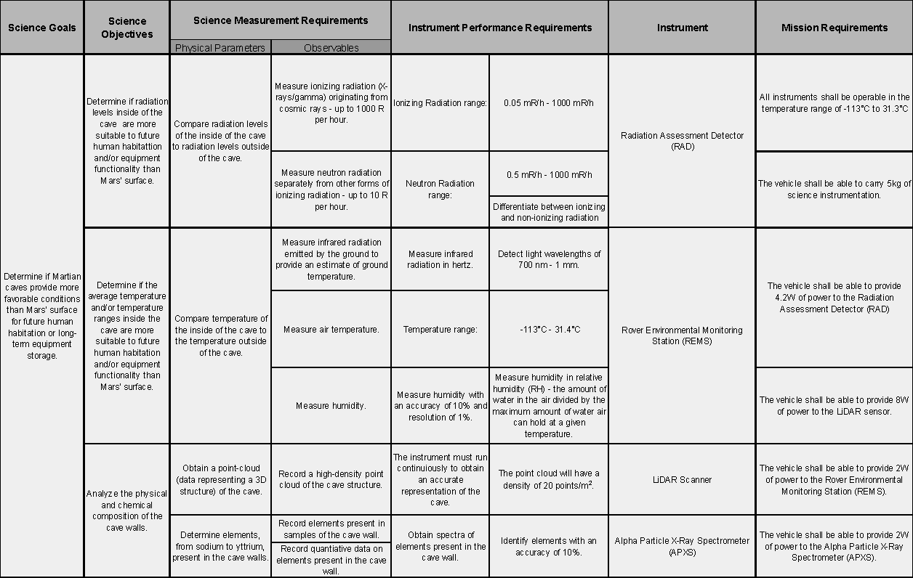

To review, there are three science objectives involved in this mission. The first deals with comparing radiation levels between the surface and caves within Mars. The second is about understanding the stability of cave structures. The last is about comparing the temperature fluctuations between the surface and caves within Mars. The radiation assessment detector was chosen as the instrument to measure levels of radiation inside and outside of the cave. The alpha particle x-ray spectrometer was chosen to find the chemical composition of rocks to see if the abundance or lack of a specific mineral, element, or compound makes a cave vulnerable to collapse. The rover environmental monitoring station was chosen to record variations in temperature throughout the day inside and outside of the cave. The LiDAR scanner was chosen to allow the concept to see its surroundings, which helps it avoid obstacles and prevent collisions with essential subsystems and instruments. It also allows the concept to produce 3D images of the cave to better understand its layout and structure.

### 4.2.3 PAYLOAD SUCCESS CRITERIA

**Radiation Assessment Detector (RAD)**

* Fifteen minutes of RAD data collected prior to cave traversal.
* Fifteen minutes of RAD data collected each hour during cave traversal.

**Rover Environmental Monitoring Station (REMS)**

* Continually collect ground temperature data with GTS (Ground Temperature Sensor).
* Continually collect wind direction data from Wind Sensor.
* Continually collect ambient air temperature data from the Air Temperature Sensor.
* Continually Collect relative humidity data from Humidity Sensor.

**LiDAR Scanner**

* The LiDAR Scanner successfully navigates the Rover in the cave during traversal.
* LiDAR Scanner obtains a point-cloud of at least 20 points per meter.

**Alpha Particle X-Ray Spectrometer (APXS)**

* Spectrometer collects geochemical compositions via emitted Alpha Particles.
* Spectrometer obtains a spectra via X-Ray of a chosen sample.

### 4.2.4 EXPERIMENTAL LOGIC, APPROACH, & METHOD OF INVESTIGATION

**Cave Selection**

The Mars Global Cave Candidate Catalog was used to select a cave for exploration. The process began by eliminating all caves except for “skylight” caves (described as “an entrance into a lava tube”) and “lateral” caves (described as “a lateral entrance often located in cliff walls”) (Cushing, 2017). Then, among the skylight and lateral caves, only candidates with a “Targeting Priority” of 0 remained within consideration. A “Targeting Priority” of 0 means that “A rating of ‘0’ indicates ‘zero priority’ because at least one HiRISE observation of the target already exists and is publicly available as of 03/2017.” (Cushing, 2017). Between the skylight and lateral cave typing, lateral was selected as the preferred type since this type could be traversed by a more conventional rover as opposed to a flying drone. Below is a cluster of lateral caves found via JMARS (9.618°N, 161.117°E).

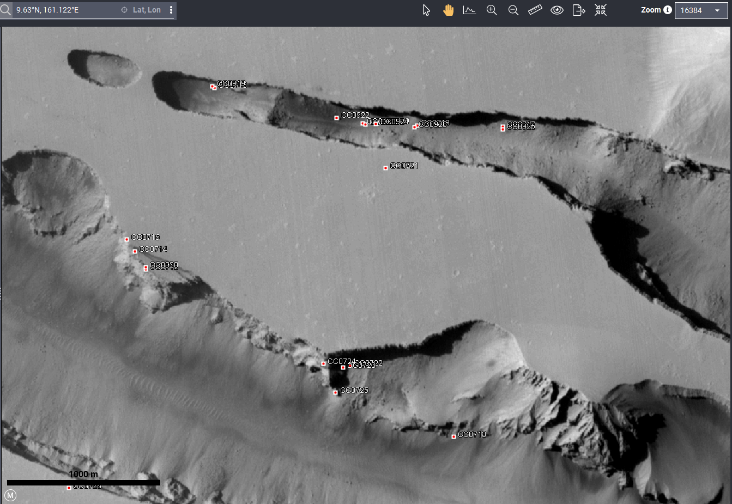

Figure 1: Lateral Cave Clusters (caves marked with red squares)

Here, the densest cluster of lateral caves with a targeting priority of 0 are listed:

| Cave Label (name) | Latitude °N | Longitude °E | Targeting Priority | Comment (from MGC3) |
| --- | --- | --- | --- | --- |
| CC0722 | 9.61913 | 161.12 | 0 | Cliff wall fractures intersect. |
| CC0723 | 9.6189 | 161.1192 | 0 | Cliff wall fractures intersect. |
| CC0724 | 9.61935 | 161.117 | 0 | Cliff wall fractures intersect. |
| CC0725 | 9.6161 | 161.1184 | 0 | Cliff wall lateral tube candidate. |

#### 

Lateral Cave Cluster (Cushing, 2017)

Selecting one of the pictured caves as the target cave allows for multiple backup caves should the original target be unviable upon vehicle arrival on Mars. CC0724 will be the target cave; the entrance appears quite large in terms of width and height (an entrance of about 90 meters)

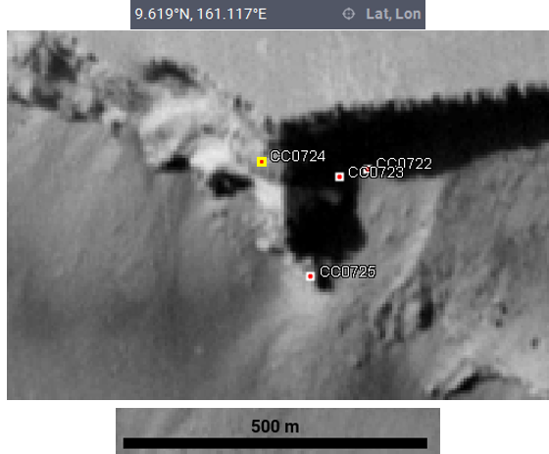

Taken in JMars GIS Software (9.619° N, 161.117 °E)

**Mission Phases**

The concept will experiment in four phases:

**Phase 1: Calibration of Instruments and Early Data Collection**

Prior to entering the cave, there are several tasks that must be completed. These will be carried out once the concept is at least one meter from the lander. The first thing that would be done is to check that all instruments are operational. The methods of calibration are mentioned in Section 4.2.5. After calibration is completed, radiation and temperature data would be collected for one hour at that location to compare surface data to cave data.

**Phase 2: Cave Traversal**

While the concept is traversing the cave, it will map the cave using the LiDAR scanner continuously until the specified location is reached. It will also collect and analyze chemical composition data with the spectrometer, which will collect data every 100 meters. The data will be relayed back to the lander during these periods. The communication nodes (mentioned in Section 3.2) will be dropped every 500 meters to ensure that the communication system remains reliable throughout the mission. Once the concept is 1.5 kilometers within the cave, it will stop and wait until the time 03:00 on Mars.

**Phase 3: Stopped Data Collection**

When the predetermined time (03:00) is reached, the remaining instruments will begin to collect data. This portion of the data collection procedure would take approximately 12 hours. The REMS instrument will face in one direction and collect temperature variation data in that area on an hourly basis. The radiation assessment detector will record radiation level fluctuations on an hourly basis. All of the data will be relayed every hour of phase 3.

**Phase 4: The Return to Cave Entrance and Deactivation**

When phase 3 ends at 13:00, the concept will once again traverse the 2.5 kilometer journey back to the entrance of the cave. On the way, it collects the communication nodes it dropped in phase 2. Once the concept returns to the lander, the concept can be deactivated. Note that the concept will not be able to communicate with the operations team after this is completed. The mission has now concluded.

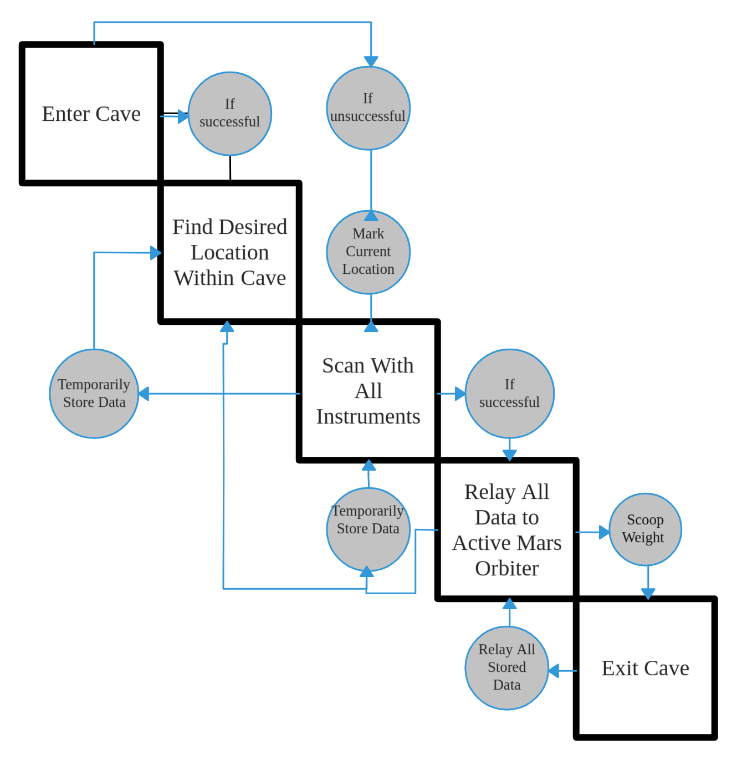

### 

### 4.2.5 TESTING & CALIBRATION MEASUREMENT

**Radiation Assessment Detector (RAD)**

RAD sub-detectors are shown below.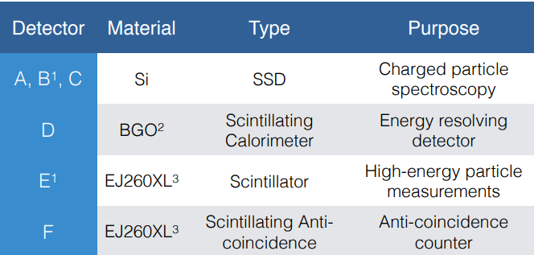

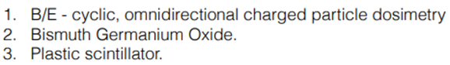

Source: (Rios, Calibration and readiness of the ISS-RAD charged particle detector - NASA)

The RAD instrument is made of several sub-detectors shown in the table above. Hardware responsiveness shall be tested using 137Cs and O at ~105 ions/spill for charged particle measurements and AmBe shall be used to test responsiveness to neutral particles (Rios, *Calibration and readiness of the ISS-RAD charged particle detector - NASA*).

Detector D can use three different calibration curves. One curve considering all ions, one curve considering only light ions, and one curve considering only heavy ions (Rios, *Calibration and readiness of the ISS-RAD charged particle detector - NASA*). The RAD used in this mission shall use the “All Points” calibration curve to accumulate the most data possible.

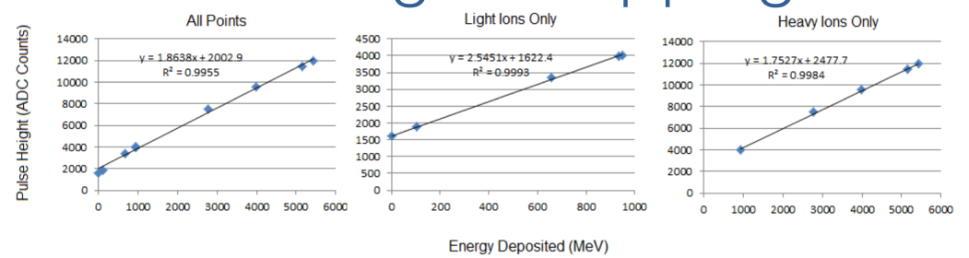

Detector D is very dense and will stop protons with energies between 18 and 120 MeV, while Detector E will stop protons with energies between 123 and 134 MeV. Since it is known that most particles traversing Detector E are penetrating particles, calibration techniques shall be similar to Detector D, but using the heavy penetrating ions calibration curve (Rios, *Calibration and readiness of the ISS-RAD charged particle detector - NASA*).

Detectors A, B, and C (the Solid-State Detectors) shall be calibrated by shining a series of different X-rays and gamma-rays of known energies into the detectors. Gamma-rays shall be produced by a radioactive source and X-rays shall be produced by fluorescence from elements excited by gamma radiation. The energy-calibration-curve coefficients shall be determined by the position of peaks produced by the Solid-State Detectors (SSDs) (Walker et al., *Rapid methods for the calibration of solid-state detectors*, 2000).

Detector F is made up of F1 (the upper, barrel shaped part) and F2 (the bottom, base part). F2 shall have a calibration nearly identical to Detector E. F1 is more difficult to calibrate since most particles do not hit F1 in the beam configuration of calibration (the beam is fired through the “top” of the instrument), but if they do, they have unknown paths through the plastic. Since F1 and F2 are composed of the same material in the same thickness, F1 and F2 shall have the same calibration (Rios, *Calibration and readiness of the ISS-RAD charged particle detector - NASA*).

**LiDAR Sensor**

LiDAR scanners require a point cloud to be recorded to be compared to known calibration points. Since there are no known calibration points on Mars (although, depending on this mission’s success, that is a possibility for a future mission concept), the LiDAR scanner must be calibrated in a facility on Earth. The LiDAR scanner shall be calibrated in a way that works well for unmanned vehicles/robotics already used on Earth. The calibration method is to use the center of a spherical target as the calibration control point; the LiDAR scanner records the whole scene with a point cloud, then the points on the calibration sphere are found in the point cloud so that the center coordinates of the sphere can be calculated (Ming Guo et al., *Accurate Calibration of a Self-Developed Vehicle-Borne LiDAR Scanning System*, 2021). Spherical points on the same scanning line are fitted into a cross-section of the calibration sphere so that a distance ratio can be calculated. The calibration method shall require a linear interpolation algorithm to function.

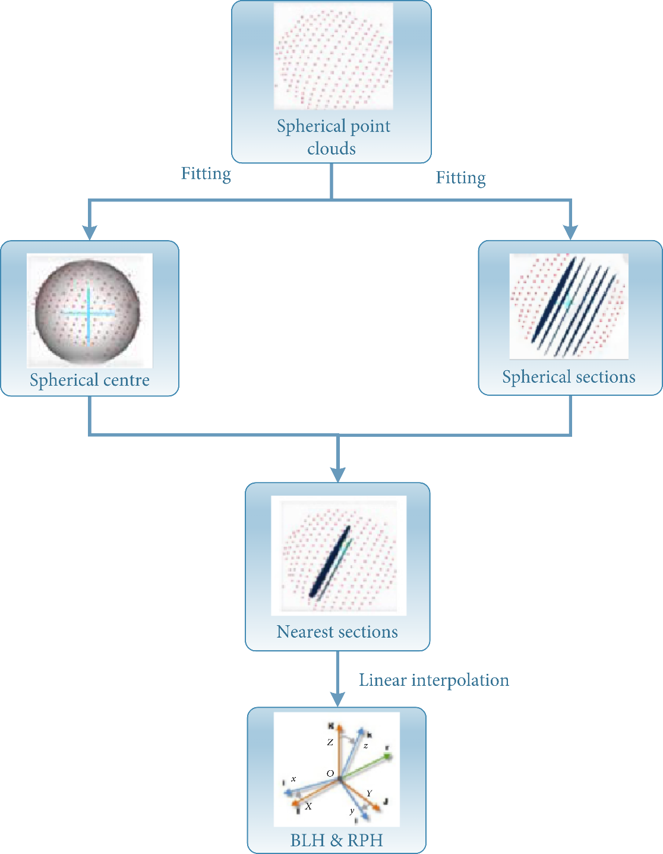

The figure shows the process of fitting the sphere from the point cloud and solving the parameters of the center

Source: (Ming Guo et al., "Accurate Calibration of a Self-Developed Vehicle-Borne LiDAR Scanning System", 2021)

**Rover Environmental Monitoring Station (REMS)**

The Ground Temperature Sensor (GTS) will measure the temperature of the floor of the target cave – the position of the GTS is shown above on one of the REMS booms. An in-flight calibration system shall be used to account for detector degradation due to dust accumulation on the instrument’s window. The field-of-view is obstructed by the calibration plate; this will minimize having heat from the vehicle interfere with measurements of ground temperature (*REMS CALIBRATION PLAN: CAB-REMS-PLN-002* *Issue 02*, 2013).

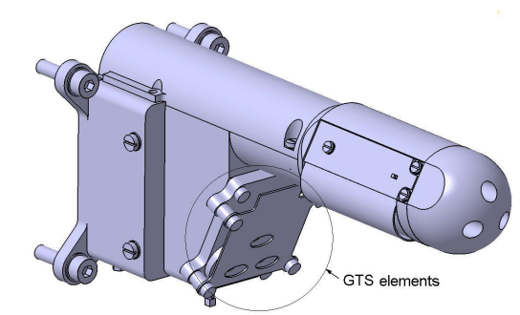

Each of the two booms has a Wind Sensor – the Wind Sensors shall be calibrated in wind tunnels using known wind speeds and within the temperature ranges expected at the mission site on Mars. Below is a figure of one of the booms undergoing calibration in a wind tunnel.

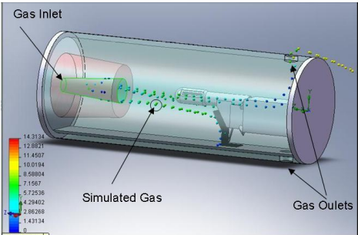

The Humidity Sensor (HS) of REMS shall be calibrated in environments of known temperature, air pressure, and humidity. The sensor head shall take readings in room temperature at six points ranging from almost dry (~0% RH) to wet (~100% RH) to get a basic calibration “shape” (Hari, et. al, *Mars Science Laboratory relative humidity observations: Initial results*, 2014). Then using the calibration shape, eight humidity readings shall be taken from -113°C to 31.3°C in ~0% RH conditions and eight more humidity readings in ~100% conditions. Dry conditions shall be provided in a vacuum chamber and wet conditions in a sealed, humidified chamber – both chambers shall have a known, controllable temperature for calibration.

The Air Temperature Sensors (ATS) are located at the “ends” (the area facing away from the rover) of the booms. To calibrate the ATS, the booms that they are located on must be heated to a known and constant temperature while the air temperature is changed and the air temperature is recorded by the ATS (*REMS CALIBRATION PLAN: CAB-REMS-PLN-002 Issue 02*, 2013). The conditions used for calibration in CAB-REMS-PLN-002 are as follows:

* Atmosphere temperature at 288K, 298K, 313K and 328K
* Mars-like pressure at 600 Pa
* Boom temperature must be set at 5K, 10K, 15K and 20K over the atmosphere temperature

**Alpha Particle X-Ray Spectrometer (APXS)**

The spectrometer will require a lab standard geological sample to periodically check the calibration and initial performance of the instrument according to elements that are needed to be observed. The sample shall be onboard the vehicle to continuously monitor its current performance throughout operation. The preliminary calibration procedure of the spectrometer shall be done in a laboratory with a given instrument. It is first necessary to calibrate the method. The specific abundance of an identified element correlates with the peak area. Throughout this step, the characteristic peaks from the spectrum are intricate. The peak fit procedure includes the determination of the detector properties such as energy calibration, peak form, and a full-width-at-half-maximum (FWHM) (Gellert et al., 2006).

Proper preflight calibration will be essential to analysis of APXS data. A mixture of gasses closely matching the composition of the martian atmosphere shall be used for all calibration measurements. The sensor head shall be cooled to a temperature below −30°C to −40°C. Atmospheric pressure could be controlled by regulating $CO_{2}$ gas pressure or by regulating a vacuum pressure below 0.01 mbar. Correlations between elemental line fluxes and compositions are required to determine the elemental composition of the sample. Geochemical samples with certified and unknown compositions shall be used to improve the sensitivity of the instruments. All calibrations will be made using the flight radiation sources. 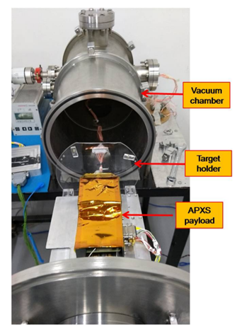

Figure 10: Experimental setup for characterization of APXS with metallic targets in vacuum chamber.

Source: (Shanmugam et al, “Alpha Particle X-Ray Spectrometer (APXS) On-board Chandrayaan-2 Rover - Pragyan”, 2019)

### 4.2.6 PRECISION & ACCURACY OF INSTRUMENTATION

**Radiation Assessment Detector (RAD)**



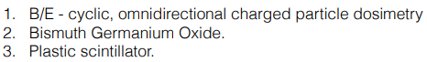

Source: (Rios, Calibration and readiness of the ISS-RAD charged particle detector - NASA)

The RAD instrument is made of several sub-detectors shown in the table above. Detector B will detect any charged particle collision above noise, it will also detect gamma rays and neutrons with limited efficiency. Detector E will also detect charged particles like Detector B, but Detector E is more efficient at detecting neutrons and less efficient at detecting gamma rays. Detectors A, B, and C are all Solid-State Detectors (SSD); SSDs are well suited for measuring ionizing radiation caused by interaction with charged particles and photons (Lutz et al., *Chapter 5: Solid State Detectors*, 2020). Detectors D, E, and F measure scintillation light; scintillation light is light emitted from ionizing radiation (Rusack, *Seeing the Light*, 2022).

**Rover Environmental Monitoring Station (REMS)**

The Ground Temperature Sensor’s (GTS’s) field-of-view will be obstructed by the calibration plate; this will minimize having heat from the vehicle interfere with measurements of ground temperature. Dust may deposit in the inner side of the calibration plate; however, the emissivity of the calibration plate’s paint is high. A small amount of dust should not modify performance by any significant amount (*REMS CALIBRATION PLAN: CAB-REMS-PLN-002 Issue 02*, 2013).

Below is a figure from the REMS Calibration Plan document demonstrating the field-of-view of the GTS. The vehicle for this mission will use a different design, but the GTS sensor will still be faced away from the vehicle, as in the figure, to prevent reading heat from the vehicle instead of the ground.

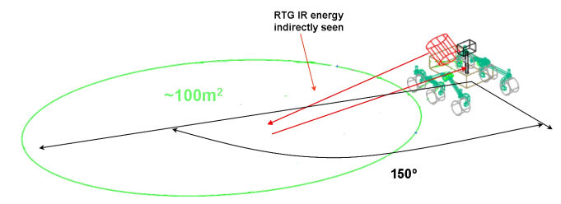

Source: (REMS CALIBRATION PLAN: CAB-REMS-PLN-002 Issue 02, 2013)

The Wind Sensors shall be calibrated and tested in facilities with wind tunnels to achieve the functional requirements for Resolution, Accuracy, and Sampling laid out in the CAB-REMS-PLN-002 document. The document also includes a Range requirement for horizontal wind direction, however, the rover for this mission will not use the REMS mast, so the coverage will not be complete. Airflow in a cave would not be omnidirectional and there is no sense in simply discarding the entire Wind Sensor since it is already built-in to the booms. Each of the two booms shall be placed on opposite sides of the rover with one Wind Sensor facing “forward” and one “backward.” Below is the accuracy/precision from the CAB-REMS-PLN-002 document followed by the accuracy/precision that will be used for this cave traversal mission.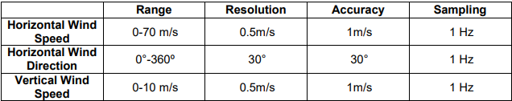

Source: (REMS CALIBRATION PLAN: CAB-REMS-PLN-002 Issue 02, 2013)

|  | Range | Resolution | Accuracy | Sampling |
| --- | --- | --- | --- | --- |
| Horizontal Wind Speed | 0 - 70 m/s | 0.5 m/s | 1 m/s | 1 Hz |
| Horizontal Wind Direction | 0 ° - 180 ° | 30 ° | 30 ° | 1 Hz |
| Vertical Wind Speed | 0 – 10 m/s | 0.5 m/s | 1 m/s | 1 Hz |

This mission’s accuracy/precision requirements.

The Humidity Sensor (HS) of REMS is based on a Vaisala Humicap® sensor head and transducer electronics. HS is a relative humidity sensor that contains an active polymer film that changes its capacitance (ratio of stored electric charge vs difference in electric potential) in response to changing humidity (*REMS CALIBRATION PLAN: CAB-REMS-PLN-002 Issue 02*, 2013). The sensor head is also temperature dependent, so it will require that accurate temperature also be reliably taken by REMS.

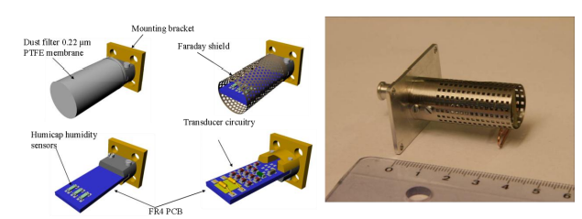

Source: (REMS CALIBRATION PLAN: CAB-REMS-PLN-002 Issue 02, 2013)

The REMS Air Temperature Sensor (ATS) shall be able to measure ambient air temperature in the range of 150K – 300K with a resolution of 0.1K and an accuracy of 5K (*REMS CALIBRATION PLAN: CAB-REMS-PLN-002 Issue 02*, 2013).

**LiDAR Sensor**

Using the method of calibration proposed by Ming Guo, there is a relative accuracy of 0.046 meters for the x-direction, 0.078 meters for the y-direction, and 0.018 meters for the elevation (z-direction). Pre-calibration accuracy vs post-calibration accuracy of the LiDAR scanner in this study is as follows

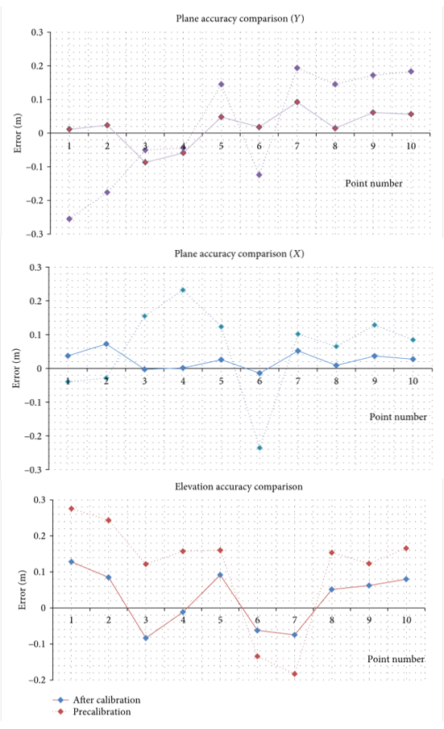

Source: Ming Guo et al., Accurate Calibration of a Self-Developed Vehicle-Borne LiDAR

**Alpha Particle X-Ray Spectrometer (APXS)**

The APXS will be fully calibrated using standard geological samples in the laboratory. Curium-244 sources for X-ray spectroscopy shall be used to determine the abundance of major and trace elements. The data analysis is theoretically well understood and delivers unambiguous element identification and accuracy on the order of ~10%, mainly limited by microscopic sample heterogeneity (i.e., grain size effects) (Gellert et al., 2006).

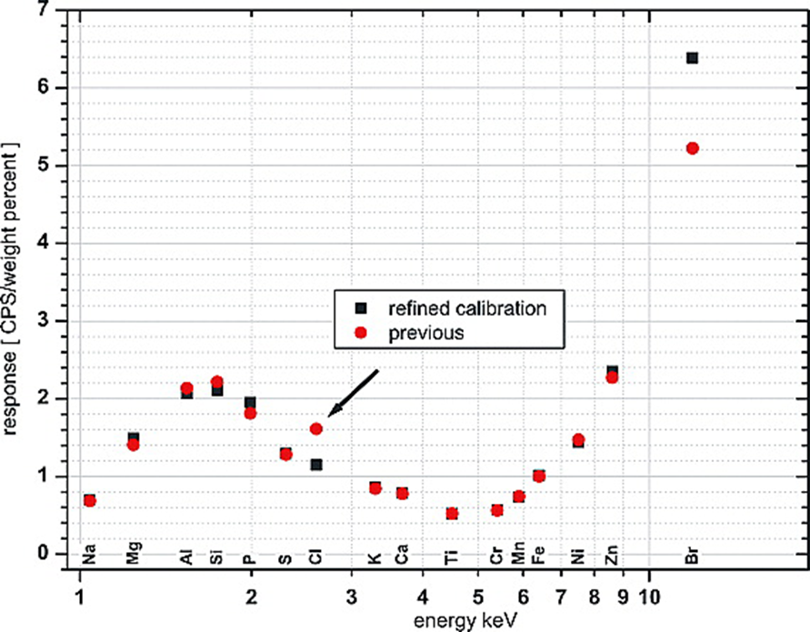

Response results of the APXS calibration.

Source: (Gellert et al, “Alpha Particle X-Ray Spectrometer (APXS): Results from Gusev crater and calibration report”, 2006)

### 4.2.7 EXPECTED DATA & ANALYSIS

**Radiation Assessment Detector (RAD)**

Raw data shall be stored in non-volatile memory (NVM) at a rate of 2 Hz while the instrument is recording data - NVM has a capacity of 4GB (Rios, *Calibration and readiness of the ISS-RAD charged particle detector - NASA*). Data stored in NVM shall be sent to Earth and processed/analyzed.

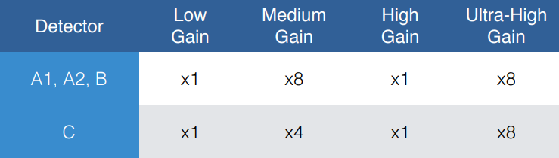

*Source: (Rios,* Calibration and readiness of the ISS-RAD charged particle detector - NASA*)*

Data from Detectors A, B, and C (the Solid-State Detectors) is read out by four VIRENA (Voltage-Input Readout for Nuclear Applications) channels. Units recorded will be in ∆E - 2 keV (a detection of ∆E of 100 keV will be recorded as 50 units) (Rios, *Calibration and readiness of the ISS-RAD charged particle detector - NASA*). The four VIRENA channels are shown in the chart below. Below the chart is an example of data received from a Solid-State Detector.

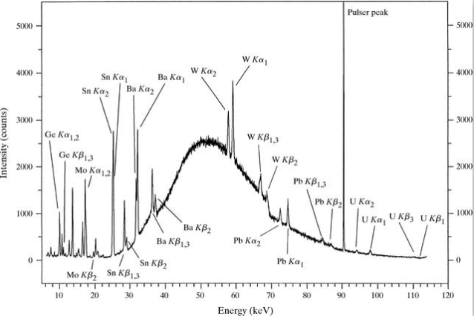

Energy-dispersive pattern collected from the uranium-containing glass using a polychromatic beam of X-rays to stimulate the fluorescence. The Pulser peak was added electronically as an aid to checking the stability of the detector electronics. The unassigned peaks at low energy are due to escape events.

Source: (Rios, *Calibration and readiness of the ISS-RAD charged particle detector - NASA*)

**Rover Environmental Monitoring Station (REMS)**

The REMS will provide data from four different types of sensors: ground temperature, wind speed/direction, humidity, and air temperature. Both of the “nodes” or “booms” have air temperature sensors and wind speed/direction sensors. Only one boom has the ground temperature sensor, while the other has the humidity sensor. In the figure below the left boom has the humidity sensor while the right boom has the ground temperature sensor.

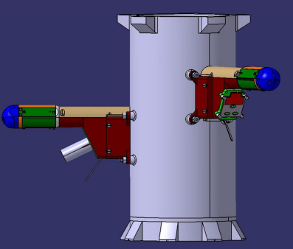

Source: (REMS CALIBRATION PLAN: CAB-REMS-PLN-002 Issue 02, 2013)

* **GTS (Ground Temperature Sensor):** Data will be received in degrees Kelvin.
* **Wind Sensor – Wind Direction:** Data will be received as an angle in the range 0 ° to 180 ° for each wind sensor.
* **Wind Sensor – Wind Speed:** Data will be received in meters per second.
* **ATS (Air Temperature Sensor) –** **Air Temperature:** Temperature data shall be obtained in degrees Kelvin with a resolution of 0.5K an accuracy of 5K.
* **Humidity Sensor –** **Relative Humidity**: 0 – 100% RH. An example of data obtained from the Humidity Sensor is shown below.

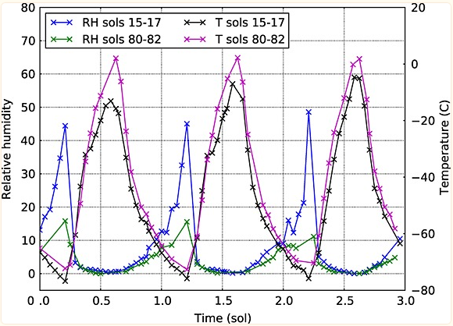

Source: (Hari, et. al, Mars Science Laboratory relative humidity observations: Initial results, 2014)

**LiDAR Scanner**

LiDAR emits lasers onto the surrounding environment, then records the time from when the laser pulse left the LiDAR to when it has returned. This allows for the calculation of 3D coordinates for the surface reflecting the laser. The vehicle will obtain a “point cloud” (a large set of 3D coordinates) to send to Earth. Below is an example of a point cloud of a cave in Niš, Serbia.

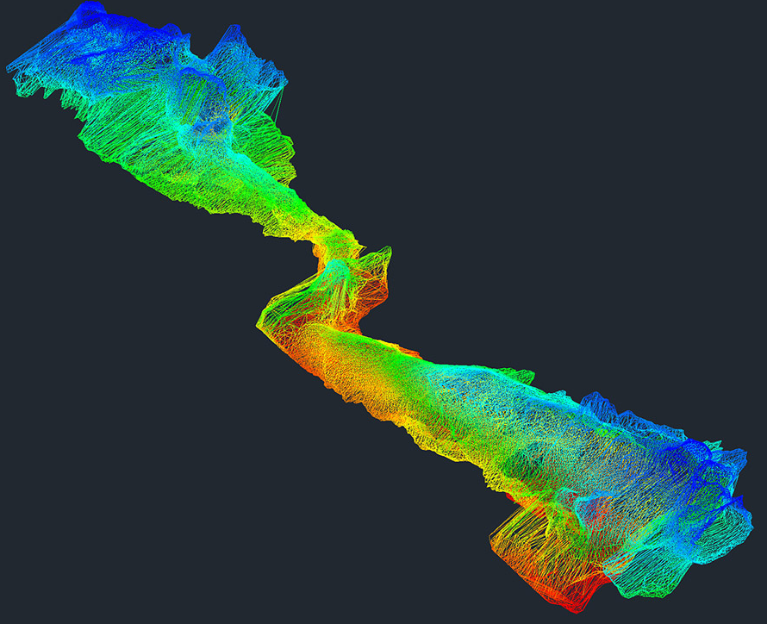

Source: (Meneely, J. (2013). Filling the Void In Cave Archaeology)

**Alpha Particle X-Ray Spectrometer (APXS)**

The APXS sensor once placed on a desired target emits Alpha Particles from the given radiation source through radioactive decay, which proceeds to collect spectra and engineering data. With a 32 kB APXS memory, the spectrometer shall collect a total of 12 – 13 spectra included in the science data (either new or old spectra). Including a temperature record measured every 30 seconds during acquisition (Gellert et al., 2006). Energy comes off in the form of X-Rays which outlines an analizable graph and its components. Below is a spectrum obtained from Gusev crater on Mars.

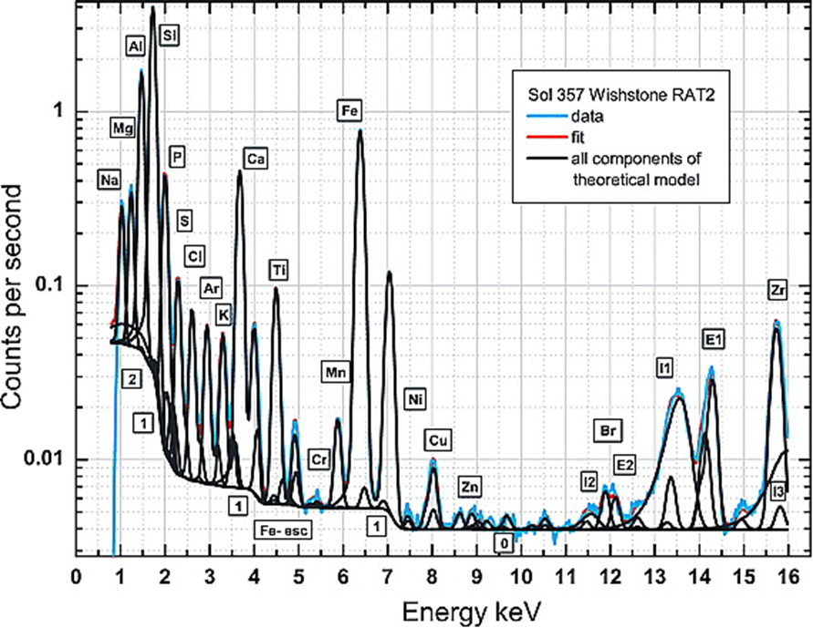

X-ray spectrum obtained on Mars together with the deconvolution model components.

Source: (Gellert et al, “Alpha Particle X-Ray Spectrometer (APXS): Results from Gusev crater and calibration report”, 2006)

# SECTION 5 - Safety



## 5.1 SAFETY OFFICER & SAFETY APPROACH

The Safety Officer of Team 21 is Sanketh Narmnada, who is responsible for ensuring that all employees are working in a safe environment by mitigating a multitude of hazards found in the workplace. There has been a lot of research going into specific personal protective equipment (PPE). This includes looking into past incidents with similar concepts and relevant testing procedures for this specific mission. General lab safety comes from past experiences with lab training in various labs at university.

## 5.2 PERSONNEL HAZARDS & MITIGATION

### 5.2.1 TRAINING PROCEDURES

All employees are required to watch a video on laboratory safety and complete an in-person assessment to prove that they understand the risks associated with their respective work environments. Employees are then to be trained by an experienced professional in each physical task. Employees must take another assessment to prove that they understand how to perform their physical duties in a safe manner. Employees will be monitored by the safety officer to ensure they are following safety procedures.

### 5.2.2 GENERAL MITIGATION (ALL FACILITIES)

* Polyester and nylon clothing materials are required
* Mental health checks are required every 3 months

### 5.2.3 MACHINING/MANUFACTURING HAZARDS & MITIGATION

| **Hazards** | **Mitigation** |
| --- | --- |
| Exposure to sharp blades | Every bladed machine is required to have a brake that activates when a blade comes into contact with skin. Employees are required to check for guards prior to using bladed machinery. |
| Dust and small particles | In areas of high foreign particles, employees are required to wear elastomeric full face piece respirators. |
| Electrical failure | Employees must wear electrical insulated rubber gloves and safety glasses. |
| Fire hazard | Class C fire extinguishers must exist every 10 meters within the facility. There must be a foam dispensing fire suppression system. There must be at least 5 entrances/exits and every window must be openable. |
| Unguarded machinery | Before operating machinery, employees must check for a guard. If a machine does not have guards, report to the safety officer and do not operate the machine. |
| Falling/dropping parts | Employees dealing with the movement of parts must wear steel-toed boots. |
| Accidental machinery start-up during maintenance | Before entering the machine, at least two people should verify that the safeguards of the machine are working as intended. At least one person must monitor the safeguards of the machine, while the technicians work. |
| Loud noises | Employees must wear earmuffs at noise levels above 85 dB. |

### 5.2.4 TESTING HAZARDS & MITIGATION

| **Hazards** | **Mitigation** |
| --- | --- |
| Radiation exposure from communications and simulation testing | Employees dealing with radiation must wear a full body hazmat suit. Each employee may work in high radiation conditions for only 2 hours during an 8 hour period. Employees must be checked for levels of radiation weekly. If the employee exceeds 97 milli-rems, the employee will not be allowed to return back to work (temporarily). |
| Extreme temperature exposure | Employees dealing with extreme temperatures must wear a full body hazmat suit. |
| Electrical exposure | Employees dealing with electrical components must wear electrical insulated rubber gloves and safety glasses. |
| Moving parts while concept is operating | Employees must maintain at least a distance of 1 yard from the concept. |
| Frequency of communications can damage biological tissues and increase body temperature when exposed for 8 continuous hours | Employees dealing with high frequency communications can only work in the environment for 4 hours within an 8 hour period. |
| Fire due to overheating | Use an internal thermometer to monitor system temperatures. Utilize Class C fire extinguishers. |

### 5.2.5 GENERAL TESTING PROCEDURES

At least three members must be available for the test procedure. One would monitor the test, while the others would carry out the procedure. When testing the concept, the procedure below must be followed:

1. Ensure that the power is off.
2. Check the electronics to ensure there is no exposed wiring or partially connected electronics (be sure to wear insulated gloves).
3. Check the condition of all areas of moving parts to ensure that there will not be any potential flying parts.
4. Once the checks have been completed…
   1. If the test does not involve a change in the external environment, all testing employees must be at least 1 meter away from the concept.
   2. If the test does involve a change in the external environment, all testing employees must exit the testing area and monitor from outside of it
5. The operator gives a warning that they are going to turn the power on. The other testing employees must acknowledge the warning by repeating the warning back to the operator.
6. The test is conducted.
7. The operator must announce that the power is off. The other testing employees must acknowledge the confirmation by repeating the warning back to the operator.
8. After the test…
   1. If the test does not involve a change in the external environment, all testing employees should check for changes in the test subject
   2. If the test does involve a change in the external environment, all testing employees must wear heavily insulated hazmat suits (as well as other appropriate PPE) and check for changes in the test subject

### 5.2.6 INJURY PROCEDURES

If an employee has been injured in a facility, the procedure below must be followed:

1. Get the employee to a safe place
2. Call for a supervisor
3. If the employee needs medical attention…
   1. Call 911 (if needed)
   2. Supervisor responsible for getting them to medical facility
4. Document the incident
5. Assess and protect scene of accident
6. Develop a plan for the employee to return to work

# SECTION 6 - Activity Plan



## 6.1 MISSION BUDGET

There were many things considered when developing the budget. One of the primary things in mind was the schedule. This influenced the amount of personnel per fiscal year, due to varying mission demands. Due to most of the focus being on developing a preliminary design at the beginning, there is not much of a demand for personnel in 2022. There are significant changes in 2023, with the engineers and scientists seeking further advice in optimizing the subsystems and science instrumentation for the mission. Computer engineers/scientists in particular are added to the team to develop the system software. In 2024, there is a slight increase in engineers and scientists to fabricate parts for the subsystems and science instrumentation. All of the subsystems and science instruments are fully assembled and individually tested by the end of 2025. Due to the decrease in manufacturing activities, the amount of personnel is lowered for this year. 2026 is reserved for the final assembly of the concept, overall concept evaluation, and the beginning of operations. Due to the high amount of testing activities in this year, there is an increase in scientists, but a decrease in engineers. The same personnel from the beginning of operations will be kept to oversee the mission operations on Mars in 2027.

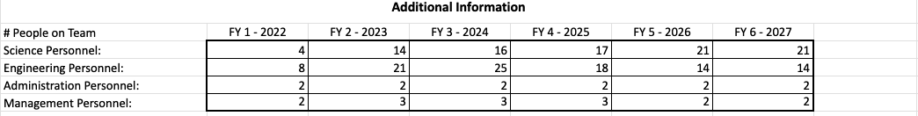

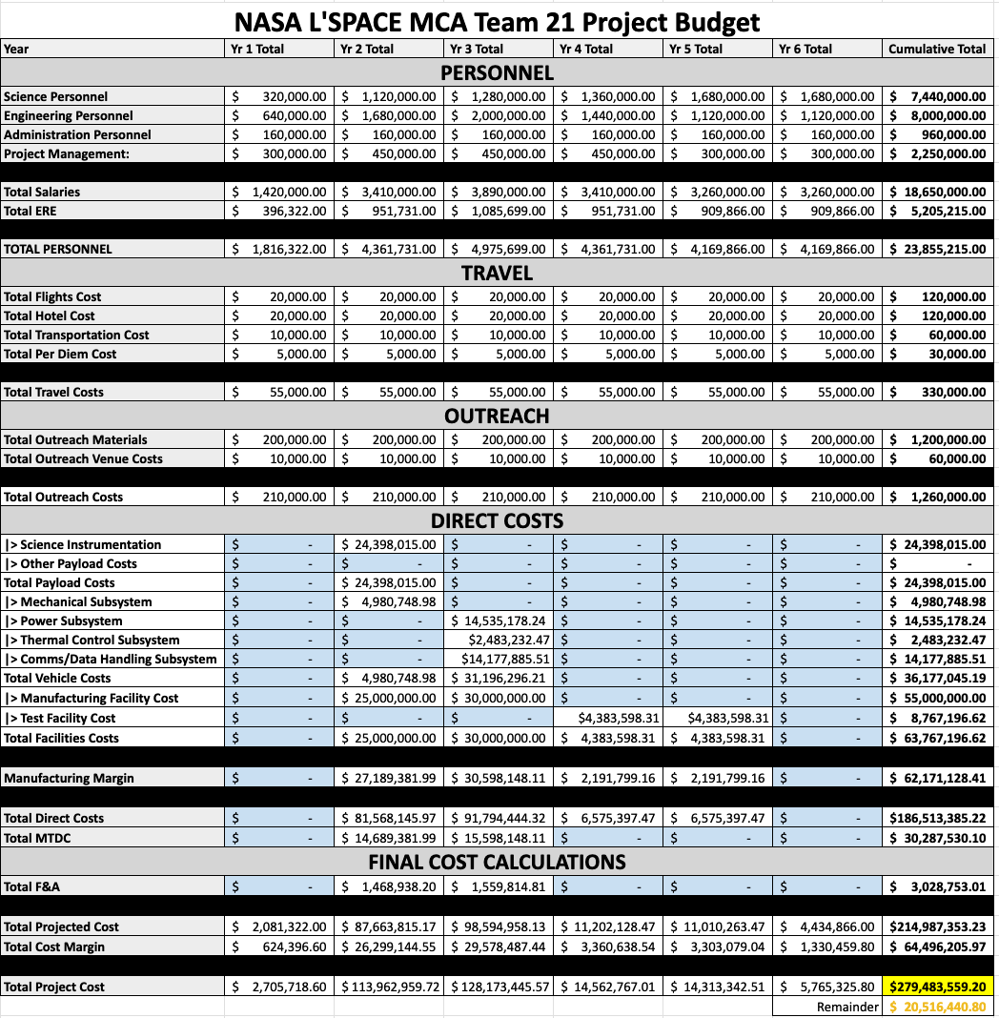

For travel, there were a few assumptions made. Assuming that the average airfare will cost around $500 for each person, the overall flight cost is predicted to be $20,000. The hotel cost is assuming a cost around $700 per person overall. The team plans to hire interns as a part of its outreach . Assuming that the team hires 5 interns that are paid $20,000 a year, the internship program will cost $100,000 per year. The team also plans to hire two animators that will be paid $40,000 to create a cartoon that describes the idea of the mission and what the team is trying to accomplish. The remainder of the outreach budget will go towards visiting underrepresented K-12 institutions in the United States for speaking events and Q&A sessions. There will also be mission merchandise that will be developed for these events.



There was no manufacturing development in 2022, so there are no direct costs that year. Fabrication of the science instrumentation and half of the subsystem parts happened in 2023. The rest of the subsystem parts will be developed in 2024. Using the NASA Instrument Cost Model (NICM), costs were estimated for developing each of the science instruments and subsystems. Testing of the subsystems and the overall concept will happen in 2025 and 2026. Due to the lack of manufacturing activities during the year of operation, there are no direct costs projected for 2027.



After everything considered, the final cost amounts to just under $280,000,000, leaving roughly $20,000,000 left over.

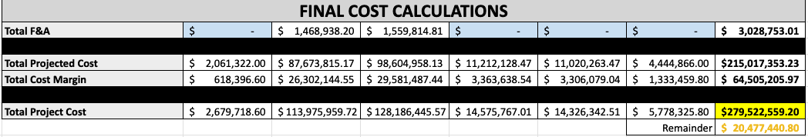

## 6.2 MISSION SCHEDULE

This schedule was developed based on the phases of the timeline. After learning that an ideal launch window to Mars would be in Q4 of 2026, the schedule was split into the different phases and tasks were created depending on the phase. Phase 1 (initial research) and 2 (design selection) fall into the year of 2022. In phase A, conceptualization begins. This is the phase where systems are researched and a cave is determined. Different options for systems are eventually developed. The concept development moves into phase 2 when trade studies are completed and a decision is made for the design choice of each of the systems. Phase 3 (preliminary design) and phase 4 (design finalization) will mostly take place during 2023. This is when the chosen idea is narrowed down into a more specific design. This phase is concluded after the design has enough specifications to define the full concept. Phase 5 (fabrication of subsystems) will begin in October 2023 and go into 2025. All of the systems and instruments will be built/purchased. Phase 6 (verification/validation and final assembly) will occur in the remainder of 2025 and continue into 2026. All systems and instruments will be tested in various environments and then assembled together to form the concept. Phase 7 (operations) will start in Q4 of 2026 and end at the beginning of Q2 of 2027. This will include the rocket’s journey to Mars and on-site operations.

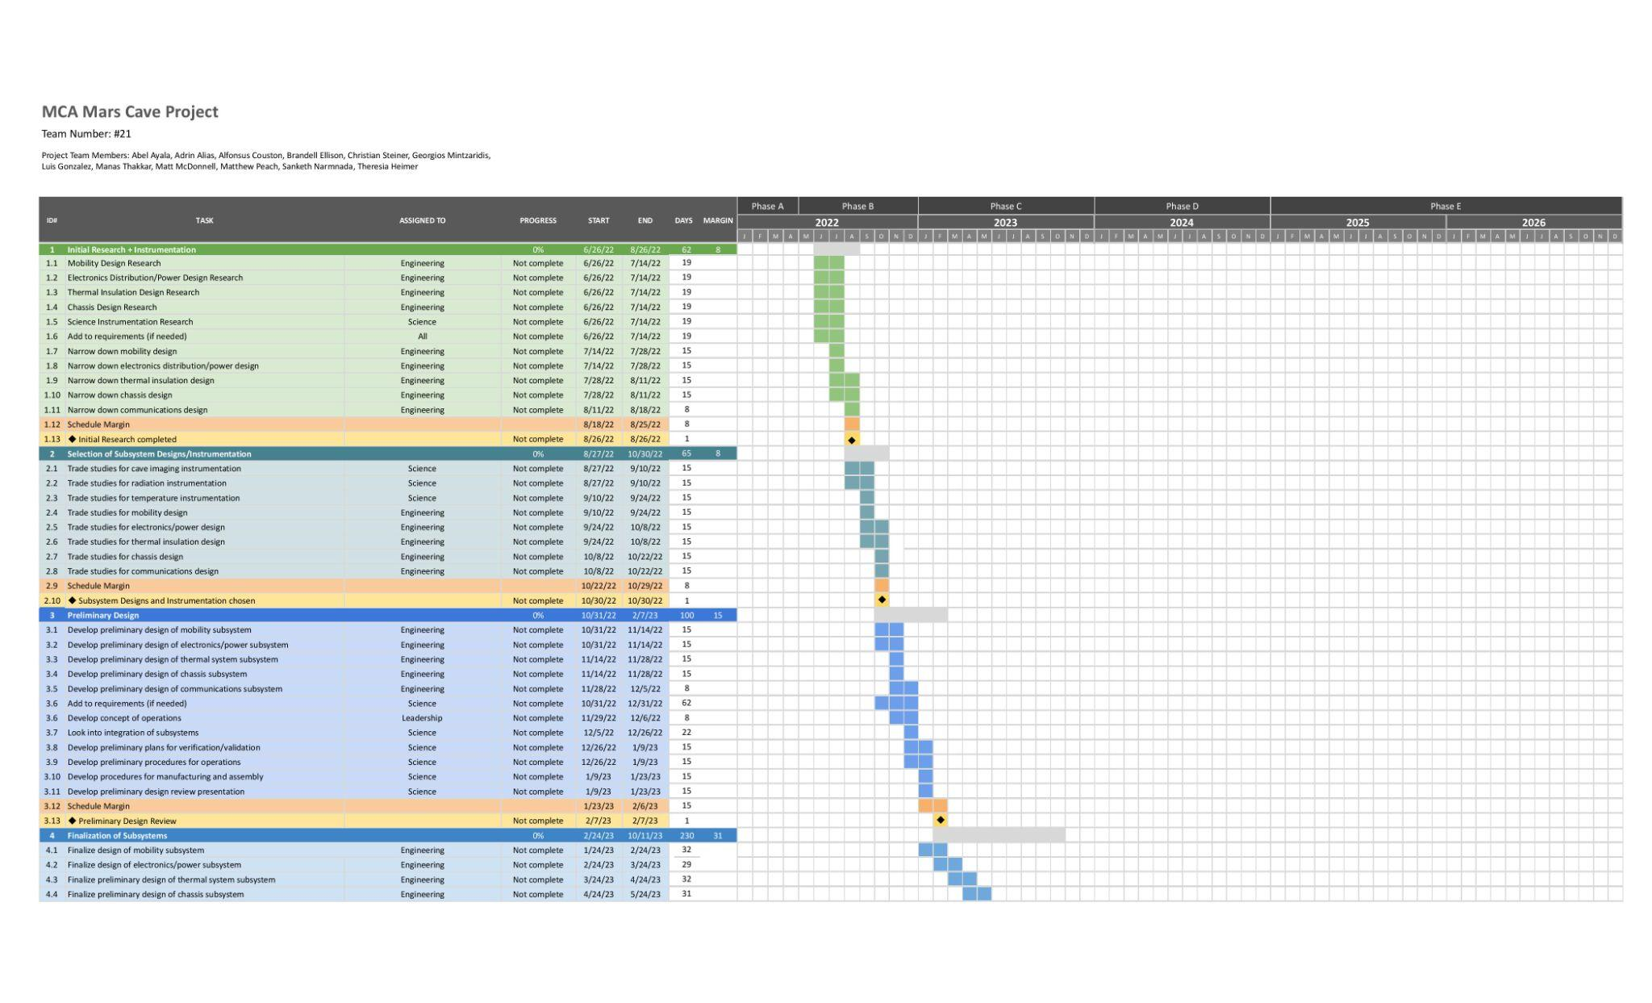

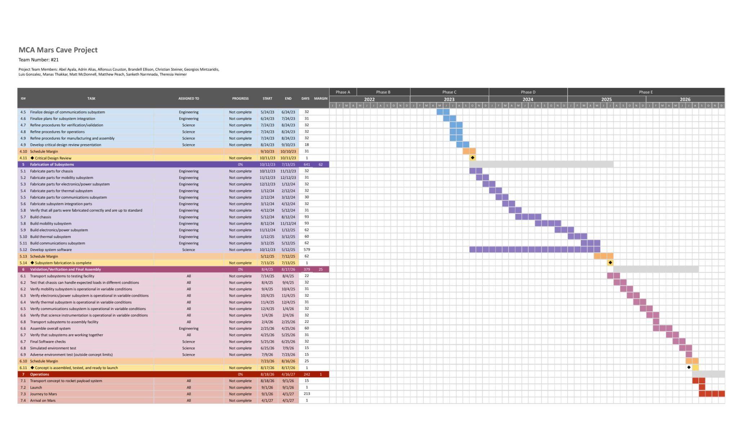

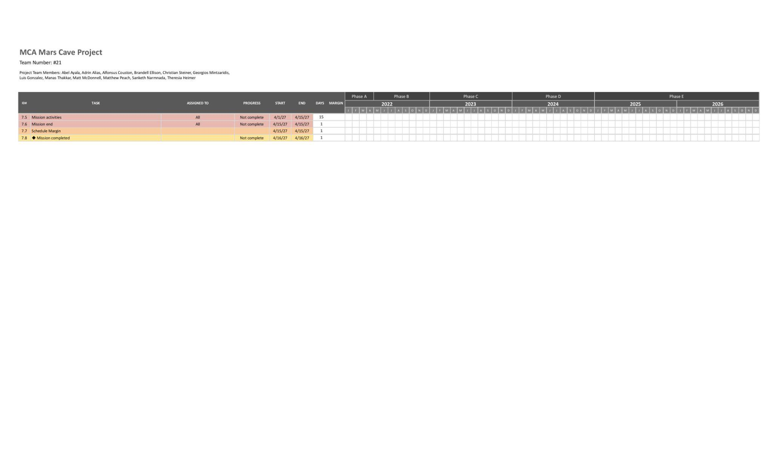

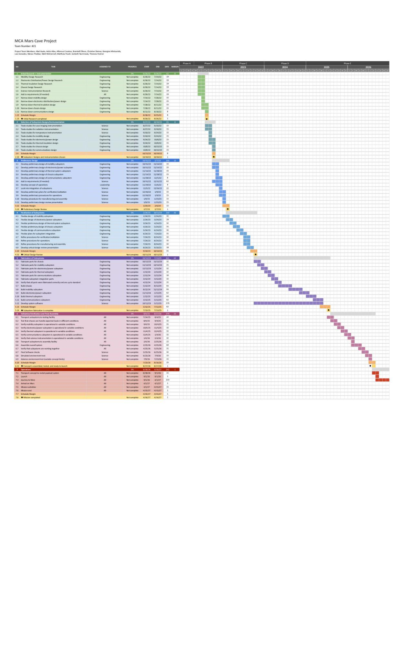

## 6.3 OUTREACH INFORMATION

### 6.3.1 OUTREACH SUMMARY

The Outreach Officer of Team 21 is Luis Gonzalez, who is responsible for sharing, promoting, and raising awareness for the mission in a public setting, as well as getting the youth excited about space exploration and the future on Mars.

### 6.3.2 OUTREACH GOALS

The outreach plan for this mission has 3 main targets: general public, K-12 students, and college students.

For the general public, to increase public awareness of the mission, cartoon-like animations explaining the importance for martian caves, their potential uses and how this mission will directly and indirectly benefit life back on Earth will be developed. Additionally, an official mission website will be created. This website will include an easy-to-use interface with the following content: About the mission, mission timeline, science, actual mission status, mission related events, get involved, galleries, and contact information. Lastly, official mission social media accounts will be created to publish images of the vehicle, selected cave, animation for kids, to engage with the public, livestream, and more content.

For K-12 students, different plans have been developed in order to engage more effectively with students from different grades and ages.

For students in grades K-4th, the outreach team will visit underrepresented schools / schools with students that come from low income families and present to them with age-adequate images about the purpose of the mission, what we hope to find, and how the results will be used. In addition, low-cost, small-scale models of the vehicle will be given to the students to get them engaged and excited about the mission and space exploration in general. This same strategy will be used for students in grades 5th-8th, with the difference that the presentation will be according to their age, meaning the presentation will be a little more formal.

For students in grades 9th-12th, the outreach team will visit underrepresented high schools and present about the mission, the science and engineering, mission status and how to get involved in the mission (internship opportunities). In addition, a limited number of science and engineering internships will be provided to high school students from underrepresented communities.

Finally, a plan has been developed to effectively engage with higher education institutions and students. Access to data collected will be provided to Minority Serving Universities (HSI, HBCUs, TCUs, AAPISIs) to perform further research. Lastly, a limited number of science and engineering internships will be provided to top college students from Minority Serving Universities.

## 6.4 PROGRAM MANAGEMENT APPROACH

### 6.4.1 TEAM ORGANIZATION CHART

The team agreed to use the campaign method suggested by the mentor to establish the structure of roles. Under this method, each member campaigned for a desired position, explaining any unique qualities that would be beneficial for the role. After two days of campaigning, the resulting team structure is the following:

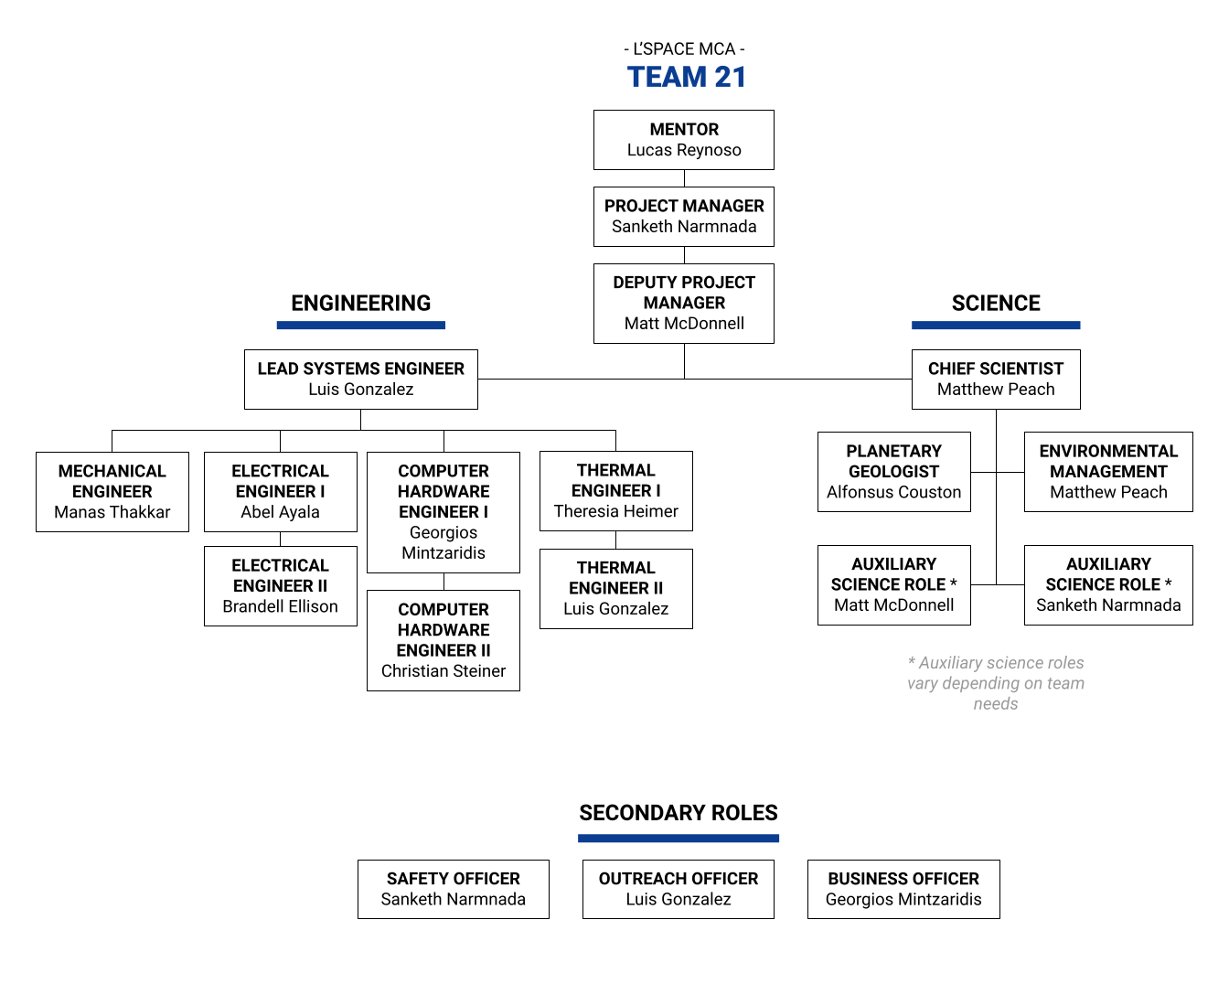

This organization chart effectively establishes a hierarchy within the team and delegates tasks to specific individuals. When finalizing the layout of the team, some additional roles were added for the members of leadership, with most adding a secondary science role. This was done to offset the high number of engineers on the team.

### 6.4.2 DECISIONS REGARDING TEAM STRUCTURE

Once the organization layout had been established, team meetings were able to move away from an onboarding-focused session to a more productive, collaborative environment. Large team meetings are balanced with the use of sub-tem check-ins and leadership team meetings. Whether work is being completed individually, in small groups, or in a large general session, the roles and delegated responsibilities help the team stay on track and on schedule.

Research and development of the different subsystems under Concept and Technology Development were assigned to the engineering team members whose disciplines or responsibilities best relate to the specific subsystems that are being developed. This form of delegation will remain consistent throughout the Academy. Science roles have also been assigned based on the amount of research that needs to be done. Roles and personnel will react to the tasks at hand to maximize the team’s ability to complete everything with precision and quality.

### 6.4.3 CHALLENGES

Large team projects are never without some challenges, especially in a remote, summer environment. The largest challenge the team may face is meeting deadlines. Due to everyone on the team having outside commitments over the summer, it may be difficult to complete high levels of research and development within a short timeframe. Another challenge could be having to redesign certain subsystems due different interpretations of solutions to problems. Each member on the team would have different approaches to solve a problem, which could lead to conflicting designs. If the designs are conflicting enough, other subsystem designs would need to be redesigned to accommodate it. The team can also expect to adjust the roles or assignments of extra personnel on tasks outside the normal scope of a position to help meet deadlines. In the event that some team members are moved outside their areas of expertise, it could pose a challenge, because the members do not have as much experience in other areas. Despite these challenges, the team can persevere by learning more about the other roles and their responsibilities, so they can be more ready to step in when the time comes. Subteams can also communicate to determine how their systems will integrate together to prevent issues in the future.

# SECTION 7 - Conclusion

# 

The purpose of this mission is to study the environment inside Martian caves, determine the stability of the structure, compare the atmosphere to that of the normal surface, and ultimately determine if these caves are more suitable for future human habitation than the surface itself. Through multiple subsystems and instruments constantly measuring levels and taking pictures of its surroundings, the rover will get a glimpse of what day-to-day “living conditions” are inside the caves.

All choices made regarding the subsystems and instruments were developed with the mission purpose and cave environment in mind. With this said, there were numerous scenarios that the team worked through. Some of these scenarios involved critical thinking about the operations of electrical components in the Mars environment, while others involved team restructuring due to evolving tasks and absences. Through the scenarios, a rover was designed to collect four modes of data that the team saw as the most important for the mission. The APXS will collect data linking spectra to specific materials. The RAD will record variations in radiation levels. The REMS will record variations in temperatures. Lastly, the LiDAR scanner will enable the concept to scan ahead for obstructions and record models that represent the structure of the cave. These instruments that were mentioned were specifically selected after looking through multiple choices and modifying our requirements.

Going forward, this team is committed to focusing on the continued research and development of these subsystems and overall vehicle design. More time, if available, would be devoted to more intricate CAD models and research into the viability of the design. For the Critical Design Review (CDR), there will be more information available regarding the use, design, and requirements of each individual subsystem and instrument, as well as a more detailed overall picture of the mission’s timeline and schedule of operations.

# REFERENCES

# 

CENTRO DE ASTROBIOLOGÍA - ASOCIADO AL NASA ASTROBIOLOGY INSTITUTE. (2013). REMS CALIBRATION PLAN: CAB-REMS-PLN-002 Issue 02. Madrid, Spain.

Cushing, G. (2017, June 1). *Mars global cave candidate catalog (MGC^3) V1 Cushing: USGS Astrogeology Science Center*. Mars Global Cave Candidate Catalog (MGC^3) v1 Cushing | USGS Astrogeology Science Center. Retrieved July 22, 2022, from https://astrogeology.usgs.gov/search/map/Mars/MarsCaveCatalog/mars_cave_catalog

Gargoum, S., & El-Basyouny, K. (2019). Effects of lidar point density on extraction of traffic signs: A sensitivity study. Transportation Research Record: Journal of the Transportation Research Board, 2673(1), 41–51. https://doi.org/10.1177/0361198118822295

Harri, A. M., Genzer, M., Kemppinen, O., Gomez-Elvira, J., Haberle, R., Polkko, J., Savijärvi, H., Rennó, N., Rodriguez-Manfredi, J. A., Schmidt, W., Richardson, M., Siili, T., Paton, M., Torre-Juarez, M., Mäkinen, T., Newman, C., Rafkin, S., Mischna, M., Merikallio, S., Haukka, H., … Urqui, R. (2014). Mars Science Laboratory relative humidity observations: Initial results. Journal of geophysical research. Planets, 119(9), 2132–2147. https://doi.org/10.1002/2013JE004514

Klingelhoefer, G. (n.d.). *Alpha Proton X-ray Spectrometer (APXS)*. NASA Space Science Data Coordinated Archive. Retrieved July 25, 2022, from https://nssdc.gsfc.nasa.gov/nmc/experiment/display.action?id=2004-006C-03

Lutz, G., Klanner, R., Fabjan, C. W., & Schopper, H. (2020). Chapter 5: Solid State Detectors. In *Particle Physics Reference Library* (Vol. 2, Ser. Detectors for Particles and Radiation, pp. 137–142). essay, Springer.

Mars Exploration Program and Jet Propulsion Laboratory. (2012). *REMS for Scientists*. NASA Science Mars Exploration Program. Retrieved July 24, 2022, from https://mars.nasa.gov/msl/spacecraft/instruments/rems/for-scientists/

Meneely, J. (2013). Filling the void in cave archaeology. Maptek. Retrieved July 31, 2022, from https://www.maptek.com/forge/june_2013/filling_the_void.html

Ming Guo, Bingnan Yan, Tengfei Zhou, Deng Pan, Guoli Wang, "Accurate Calibration of a Self-Developed Vehicle-Borne LiDAR Scanning System", Journal of Sensors, vol. 2021, Article ID 8816063, 18 pages, 2021. https://doi.org/10.1155/2021/8816063

NASA. (2021, April 15). *RAD for Scientists*. NASA Science Mars Exploration Program. Retrieved July 23, 2022, from https://mars.nasa.gov/msl/spacecraft/instruments/rad/for-scientists/

NASA. (2021, April 9). *REMS*. NASA Science Mars Exploration Program. Retrieved July 23, 2022, from https://mars.nasa.gov/msl/spacecraft/instruments/rems/#:~:text=MEDLI-,REMS,meteorological%20conditions%20around%20the%20rover.

NASA. (n.d.). *Alpha Particle X-ray Spectrometer (APXS)*. NASA Mars Exploration Rovers. Retrieved July 23, 2022, from https://mars.nasa.gov/mer/mission/instruments/apxs/

NASA. (n.d.). *PDS: Instrument information*. Planetary Data System. Retrieved July 25, 2022, from https://pds.nasa.gov/ds-view/pds/viewInstrumentProfile.jsp?INSTRUMENT_ID=APXS&INSTRUMENT_HOST_ID=MER1

Rios, R. (n.d.). *Calibration and readiness of the ISS-RAD charged particle detector - NASA*. ISS-RAD: Charged Particle Detector. Retrieved July 26, 2022, from https://ntrs.nasa.gov/api/citations/20150016969/downloads/20150016969.pdf

Rodriguez-Manfredi, J. A. (2013). *PDS: Data Set Information*. Planetary Data System. Retrieved July 25, 2022, from https://pds.nasa.gov/ds-view/pds/viewProfile.jsp?dsid=MSL-M-REMS-2-EDR-V1.0

Rusack, R. (2022, July). *Seeing the Light*. *Lecture 2 - The Physics of Detectors*. Minneapolis, MN; University of Minnesota. Retrieved from https://indico.cern.ch/event/518648/attachments/1271861/1885030/Lecture3-Scintillators-Light-Detection.pptx.pdf.

Shanmugam, M., Sripada, V. S. M., Acharya, Y. B., & Goyal, S. K. (2012, July). *APXS on board chandrayaan-2 Rover*. NASA/ADS. Retrieved July 25, 2022, from https://ui.adsabs.harvard.edu/abs/2012cosp...39.1759S/abstract

Walker, D., Clark, S. M., Jones, R. L., & Cranswick, L. M. (2000). Rapid methods for the calibration of solid-state detectors. *Journal of Synchrotron Radiation*, *7*(1), 18–21. https://doi.org/10.1107/s0909049599014636

Washington University in St. Louis - PDS Geosciences Node. (n.d.). *Alpha Particle X-ray Spectrometer (APXS)*. Analyst's Notebook. Retrieved July 23, 2022, from https://an.rsl.wustl.edu/help/Content/About%20the%20mission/MER/Instruments/MER%20APXS.htm